

GeoFarm-IS: An Agricultural Management System
With GIS and Predictive Analytics
_______________________________________________________
A Capstone Project
Presented to the Faculty of
Bachelor of Science in Information Technology Program
Isabela State University – Ilagan Campus
City of Ilagan, Isabela
_______________________________________________________
In Partial Fulfillment
Of the Requirements for the Degree of
BACHELOR OF SCIENCE IN INFORMATION TECHNOLOGY
_______________________________________________________
By:
BERONIA, RENATO JR. P.
NOLEAL, CHARLES EDWARD C.
Adviser:
ORFEL L. BEJARIN, DIT
TABLE OF CONTENTS
Title Page i
Table of Contents ii
CHAPTER I – THE PROBLEM AND ITS BACKGROUND
Introduction 3
Objectives of the Study 5
Scope and Limitation 6
Significance of the Study 8
Review of Related Literature and Studies 9
Definition of Terms 14
CHAPTER II – TECHNICAL BACKGROUND
Conceptual Framework 16
Research Paradigm 17
System Architecture 19
Context Diagram 21
Data Flow Diagram 22
Use Case Diagram 28
Entity Relationship Diagram 29
Database Schema 32
GANTT Chart 46
CHAPTER III – METHODOLOGY
Software Development Methodology 57
Requirements Gathering 58
Implementation and Deployment 66
Respondents of the Study 68
Sampling Technique 68
Statistical Treatment 69
References 71

CHAPTER I
THE PROBLEM AND ITS BACKGROUND

Introduction

Agriculture remains one of the main sources of livelihood in the Municipality of Tumauini, Isabela. Many households in the area depend on rice, corn, vegetable production, livestock raising, and other farm-related activities. Because of this, the records handled by the Municipal Agriculture Office are not only administrative files; they are also important references for planning, monitoring, assistance distribution, and local agricultural support.

At present, several activities in the Agriculture Office still depend on paper forms, spreadsheet files, and separate record-keeping. Farmer registration, farm parcel information, crop season records, livestock inventories, and assistance histories are often encoded and updated manually. This setup can lead to repeated encoding, misplaced or inconsistent entries, slower retrieval of records, and difficulty in preparing updated reports when the office needs them immediately.

Another gap is the limited visibility of farm locations and agricultural activities across barangays. Without an interactive mapping tool, it is difficult for the office to view where farms are located, what crops are commonly planted in a specific area, and which barangays require closer monitoring. This affects the office when it prepares field visits, validates records, or plans support programs based on actual farm distribution.

The office also needs better use of historical farm data. Seasonal crop records, yield information, input costs, livestock records, and previous assistance received by farmers can help identify farmers who may be close to operating at a loss, locally described as "palugi." However, when these data are stored in separate files, the office has limited basis for early warning, crop recommendations, and timely intervention. Farmers affected by crop damage may also need clearer records, such as documented damage, farm inputs, and estimated net proceeds, when seeking assistance or insurance-related support.

Basic spreadsheet files and standalone digital records can help store data, but they do not fully address the need for centralized records, spatial monitoring, predictive analysis, and accountable assistance tracking. Commercial farm management platforms may also be difficult to adopt because they are often costly, designed for private farm operations, or not aligned with local government procedures and Philippine agricultural reporting requirements.

In response to these needs, this study proposes GeoFarm-IS, a web-based agricultural management system with geographic information system (GIS) and predictive analytics for the LGU Agriculture Office of Tumauini, Isabela. The proposed system is intended to digitize farmer registration, provide QR-based farmer identification, organize seasonal crop and livestock records, show farm information through GIS mapping, and use available records to identify farmers who may need early assistance or technical guidance.

The rationale for proposing GeoFarm-IS is therefore based on the need for a more organized, accessible, and evidence-based tool for local agricultural management. Through centralized records, mapped farm information, predictive risk indicators, and report generation, the system aims to support both the farmers and the Agriculture Office in making faster and better-informed decisions. The study is also guided by relevant agricultural policies and registry requirements, including the Agriculture and Fisheries Modernization Act and the Registry System for Basic Sectors in Agriculture.

Objectives of the Study
This study aims to develop GeoFarm-IS, a web-based Agricultural Management System with GIS and Predictive Analytics, to support farmer registration, farm mapping, seasonal agricultural monitoring, assistance tracking, and early identification of farmers at risk of financial loss in the LGU Agriculture Office of Tumauini, Isabela.
Specifically, this study seeks to:
- Determine the operational problems, gaps, and requirements of the existing farmer registration, farm mapping, seasonal tracking, analytics, assistance distribution, and reporting processes of the Municipal Agriculture Office of Tumauini, Isabela.
1.1 Manual farmer registration and data encoding processes;
1.2 Paper-based and fragmented record-keeping systems;
1.3 Farm parcel mapping and location tracking methods;
1.4 Seasonal crop and livestock data recording and retrieval;
1.5 Assistance distribution monitoring and documentation;
1.6 Report generation and data accessibility for decision-making;
1.7 Identification of farmers at risk of financial loss ("palugi");
1.8 Client satisfaction and service delivery time in processing agricultural requests.
- Develop GeoFarm-IS with the following modules:
2.1 Farmer Registry and QR Code Management;
2.2 Seasonal Agricultural Tracking;
2.3 GIS Mapping;
2.4 Predictive Farmer Analytics and Crop Recommendations; and
2.5 Financial Assistance, Livestock Tracking, Reports, and Dashboard.
- Test the functionality of the developed system to validate whether it meets the defined requirements through:
3.1 Unit or functionality testing;
3.2 Alpha testing and beta testing.
- Evaluate the extent of compliance of the developed system with ISO 25010 quality standards and relevant agricultural data requirements in terms of:
  - Functional Suitability
4.2 Performance Efficiency
4.3 Compatibility
4.4 Usability
4.5 Reliability
4.6 Security
4.7 Maintainability and
4.8 Portability

Scope and Limitation
This study covers the design, development, testing, and deployment of GeoFarm-IS for the LGU Agriculture Office of Tumauini, Isabela. The system is intended for the following users: system administrators, agriculture office staff or data encoders, municipal-level viewers such as the Municipal Agriculturist and authorized planning officials, and registered farmers who will be allowed to view their own status and related records.
The study focuses on five major functional areas aligned with the objectives of the study: Farmer Registry and QR Code Management, Seasonal Agricultural Tracking, GIS Mapping, Predictive Farmer Analytics, and Financial Assistance and Livestock Tracking with report generation. The Farmer Registry will cover basic farmer profile data, RSBSA-related information, farm parcel details, organization membership, and QR-coded identification. Seasonal tracking will cover crop records, production data, input information, livestock inventory, and related agricultural assets.
The GIS component is limited to farm parcels and barangay-level agricultural information within Tumauini. The map will use encoded or GPS-collected coordinates and will provide interactive viewing, filtering, and visualization of farm locations, crop distribution, and livestock-related data. It will not use real-time satellite imagery, drone imagery, or automated remote sensing analysis. Map accuracy will depend on the correctness of the coordinates and records provided to the researchers and the Agriculture Office.
The predictive analytics component will use available seasonal production records, input costs, yield history, previous crop performance, assistance history, and documented damage records to classify farmers according to risk level. The system may also provide basic recommendations or insights based on previous cropping data, such as crops or farmers that require closer monitoring. These outputs will serve only as decision-support information and will not replace the judgment of agricultural technicians, insurance adjusters, or official government evaluators. For insurance-related support, the system will only help organize evidence such as damage records, farm inputs, and estimated net proceeds; it will not automatically approve insurance claims.
The financial assistance module will record assistance programs, farmer beneficiaries, claim status, and distribution history. The basis for distribution may include eligibility records, barangay allocation, crop or livestock profile, risk classification, verified damage, available program budget, and the decision of authorized Agriculture Office personnel. The system will provide an audit trail and reports, but actual approval and release of assistance will remain under the authority of the LGU Agriculture Office.
The system will be web-based and accessible through desktop and laptop computers using a modern web browser and internet or local network connectivity. It will not include a dedicated native mobile application for Android or iOS, although the interface may be made responsive for basic viewing on mobile devices. It will also not directly integrate with external systems such as the DA RSBSA database, PCIC database, market price monitoring platforms, or farm input supply chain systems. The study is delimited to Tumauini, Isabela and will not include implementation in other municipalities.

Significance of the Study
This study is significant in demonstrating the practical application of information and communication technology to address long-standing inefficiencies in local agricultural management. The developed system is expected to benefit the following stakeholders:
Farmers of Tumauini, Isabela – Farmers will receive QR-coded identification cards enabling faster, paperless transactions with the Agriculture Office. They will also benefit from clearer access to their records, status, previous crop information, and basic recommendations or alerts when they are identified as at risk of financial loss. These records may help them explain their production situation when seeking assistance or insurance-related support.
LGU Agriculture Office Staff – Agricultural staff will benefit from a centralized, automated system for managing farmer registrations, tracking seasonal agricultural data, monitoring livestock, recording assistance distribution, and generating official reports. The system will reduce repeated encoding and provide a clearer basis for prioritizing support such as fertilizers, seeds, cash assistance, or other agricultural programs.
Municipal Agriculturist and Planning Officers – These officers will gain access to real-time GIS visualizations of agricultural land use, crop distribution, and at-risk farmer identification, enabling evidence-based decision-making and the timely design of proactive intervention strategies.
Office of the Mayor and Municipal Council – Local officials will receive accurate and current data on agricultural productivity and farmer welfare to support policy-making, budget allocation, and agricultural program planning.
Department of Agriculture (DA) Regional Office – As an indirect beneficiary, the DA regional office can utilize consolidated farmer profile data, production trends, and intervention needs reported by the system for regional agricultural planning and program implementation.
Philippine Crop Insurance Corporation (PCIC) – Accurate farmer and crop data maintained in GeoFarm-IS can streamline insurance enrollment and claims processing for farmers affected by calamities or production losses.
Future Researchers and Students – The system and its full implementation serve as a replicable case study for ICT applications in local agricultural management, GIS integration for rural development, and the use of predictive analytics for social good in the Philippine context.
Consumers and the General Public – By supporting farmers in mitigating losses and increasing production efficiency, GeoFarm-IS indirectly contributes to food security and price stability within the municipality and surrounding communities.

Review of Related Literatures and Studies

The review of related literature and studies is organized according to the main concerns addressed by GeoFarm-IS: farmer information systems, GIS use in agriculture, predictive analytics for risk monitoring, digital agriculture policies, and software development and evaluation. The discussion presents the relationship of these works to the proposed system and ends with a synthesis of the similarities, differences, gaps, and contribution of this study.

Agricultural Information Systems and Farmer Registries

Agricultural information systems are used to organize farm-related data and support decision-making among farmers, extension workers, and government agencies. Banson et al. (2021) noted that information systems in agriculture improve data access and coordination, especially when records are updated regularly and used for planning. In the Philippine local government setting, farmer registries are important because they provide the basis for profiling, program eligibility, assistance distribution, and reporting.

The Philippine government has recognized the critical role of farmer registries in agricultural governance. The Registry System for Basic Sectors in Agriculture (RSBSA) serves as the official electronic compilation of information on the Department of Agriculture's primary stakeholders—farmers, farmworkers, fisherfolk, and agri-youth (DA Memorandum Order No. 07, Series of 2024). It contains personal and socio-economic information, agri-fishery activities, livelihood information, and records of interventions received. As of June 2024, over 10.9 million farmers nationwide are registered under the RSBSA, which serves as a reference platform for programming agricultural programs and identifying farmers eligible for DA assistance. The RSBSA also serves as a requirement and basis for implementing various programs such as providing production input and financial assistance, insurance services, and other interventions that cater to Filipino farmers and fisherfolk.

Delos Reyes and Sanchez (2022) showed that a web-based farmer registry can reduce processing delays and inconsistencies compared with paper-based records. Santos et al. (2023) also emphasized the value of digitized farmer data in relation to RSBSA implementation, particularly in improving the accuracy of farmer profiles and access to agricultural programs. These studies are closely related to GeoFarm-IS because the proposed system also starts from the need to replace scattered forms and spreadsheet files with a centralized farmer registry.

The Department of Agriculture has been actively updating its electronic database of farmers and fisherfolk to better plan and implement projects and interventions. In 2024, the DA began mobilizing some 16,000 staff nationwide to fast-track the delayed collection, updating, and validation of stakeholders' personal and farm data. Latest estimates suggest there are about 10 million farmers and fisherfolk, many of whom are identified as the poorest in the country. The DA had an initial list of only 1.4 million stakeholders before the update started, highlighting the significant gap in accurate farmer registration. The registration and updating of records and profiles of farmers, farmworkers, fisherfolk, and agri-youth will determine if these estimates are correct and help identify those who truly deserve DA assistance. Agriculture Secretary Francisco P. Tiu Laurel, Jr., a firm believer in digitalizing DA operations, has endorsed the digitalization project, confident it will improve efficiency in DA's operations, project implementation, and monitoring.

Other studies focus on specific functions needed in farmer record systems. Rivera et al. (2023) discussed the design of farmer profiling systems for municipal agriculture offices, while Reyes et al. (2020) reported the usefulness of QR code integration in speeding up farmer identification during transactions. Cruz and Mendoza (2021), Gomez and Torres (2020), and Mendoza and Garcia (2022) further pointed out that agricultural data systems must consider extension work, rural data collection, and data governance. These works support the inclusion of farmer profiles, QR-coded identification, role-based records, and accountable data handling in GeoFarm-IS.

Recent initiatives also demonstrate the growing adoption of digital systems for farmer data management. The Department of Science and Technology launched iMULA (Information System for Management and Utilization of Land and Agri-data), a multi-user web and mobile application that supports the collection, management, and maintenance of key agricultural data including farmer profiles, crops, livestock, and other information. The system features dissemination of LGU advisories, automated report generation, and streamlined submission of damage reports. Similarly, the Province of Pampanga developed an integrated agricultural data system that consolidates farmer profiles from local government units and integrates GIS mapping of farmlands for more accurate planning, monitoring, and reporting, especially during disasters. Currently, more than 44,000 farmers in the province are registered under the RSBSA, which provides a key database for targeting agricultural support and interventions.

In addition, the DA has implemented the RSBSA Profiling Platform for Local Government Units (RSBSAPP-LGU), an online application used to facilitate the registration of farmers in support of the updating of the RSBSA. This platform is aimed to be used by local government units for encoding of new registration and updating of existing RSBSA records. These developments underscore the national priority placed on accurate farmer registration and the value of digital systems in achieving this goal—directly supporting the rationale for GeoFarm-IS.

Geographic Information Systems in Agriculture

GIS is widely used in agriculture because farm information often depends on location. Burrough and McDonnell (2020) and Longley et al. (2022) explain that GIS supports the capture, storage, analysis, and display of spatial data. In agricultural management, this means that land parcels, crop distribution, livestock density, and field-level activities can be viewed not only as records but also as mapped information.

The Philippine government has recognized the transformative potential of GIS and geospatial technologies in agriculture. In 2024, the Department of Agriculture entered into a partnership with the Philippine Space Agency (PhilSA) to use advanced space technology to increase farm productivity, improve resource utilization, and enhance project monitoring. The partnership involves joint research, exchange of expertise and information, capacity-building exercises, and project implementation focused on monitoring farm-to-market roads and major agricultural commodities such as onion and corn, utilizing space technology, remote sensing, and sophisticated agricultural systems. Agriculture Secretary Francisco P. Tiu Laurel Jr. emphasized that digital agriculture is essential to unlock opportunities for farmers and fisherfolk, providing them with tools and knowledge to increase productivity.

Studies in the Philippine setting show the relevance of GIS to local agricultural planning. Sarmiento et al. (2022) conducted geospatial analysis of crop distribution and productivity in Isabela, which demonstrates that agricultural mapping is applicable to the region where this study is situated. De la Cruz and Ramos (2023) discussed GIS-based agricultural land use mapping in the Philippines, including the use of collected coordinates as practical data for local mapping. These studies support the mapping component of GeoFarm-IS for farm parcels and barangay-level agricultural monitoring.

Corpuz and Lontoc (2021) and Bautista et al. (2022) presented web-based GIS platforms for agricultural resource management and land use planning. Their work is relevant to GeoFarm-IS because the proposed system also uses open-source and web-based mapping tools suitable for local government offices with limited resources. Unlike systems focused mainly on land use maps, however, GeoFarm-IS connects the map with farmer profiles, crop seasons, livestock records, and assistance data.

The National Economic and Development Authority (NEDA) has also recognized the value of remote-sensing technologies in agriculture. Project SARAI (Smarter Approaches to Reinvigorate Agriculture as an Industry in the Philippines) implements a near real-time monitoring of production areas using remotely-sensed images. Project SARAI aims to collect crop production data through crowdsourcing using their mobile application, Bantay SARAI, which serves as a tool for farmers to report their crop planting date, expected harvest date, anticipated yield, and damages. Project SARAI provides crop advisories for nine commodities, namely rice, corn, banana, coconut, coffee, cacao, sugarcane, soybean, and tomato.

In 2023, NEDA approved funding for four agri-tech solution projects under its Innovation Grants, including "Project GeoMap: Geospatial Mapping and Information System for Precise Farming and Smart Agriculture" from Samar State University and "Artificial Intelligence for Impact-based forecasting and early warning system for inclusive finance and strengthening of local economic development in Rice-Based Farming Communities" from the Philippine Rice Research Institute. These initiatives demonstrate the government's commitment to integrating geospatial technologies into agricultural management and decision-making.

A GIS-based land suitability model for agricultural tractors in the CALABARZON Region was also developed, focusing on determining suitable lowland rice areas for two-wheel and four-wheel tractors. This model can be utilized by the government to improve its machine distribution programs. These developments highlight the growing recognition of GIS as an essential tool for agricultural planning and resource allocation at the local level.

Predictive Analytics in Agriculture

Predictive analytics has become useful in agriculture because it helps convert historical data into warnings, classifications, and planning support. Liakos et al. (2022), Kamilaris and Prenafeta-Boldu (2021), and Chlingaryan et al. (2020) reviewed the use of machine learning and data-based approaches in agriculture, including crop yield prediction and agricultural risk assessment. These studies show that predictive tools can support decision-making, although the required data quality and technical capacity must be considered.

In developing countries, predictive analytics is increasingly being adopted to address agricultural challenges. For instance, the web-based Africa Agriculture Watch (AAgWa) platform has provided predictions for agricultural yields in 47 African countries across many of the most important crops for African food production, including maize, cassava, and sorghum. Studies have also implemented various regression models—Linear, Tree, Gradient Descent, Gradient Boosting, K Nearest Neighbors, and Random Forest—to predict crop yields in 37 developing countries over 27 years. Ensemble machine learning approaches have been developed for effective prediction of suitable agricultural crop cultivation in countries whose economies rely on agriculture. These studies demonstrate that predictive analytics can be successfully applied in resource-constrained settings.

For local and resource-constrained settings, simpler and interpretable models are often more practical than complex algorithms. Dela Peña et al. (2022) developed a farmer risk prediction model using historical agricultural data, while Garcia and Santos (2021) identified at-risk farmers using data mining techniques. Lopez et al. (2023) also found that crop loss prediction can be supported by local historical data and seasonal patterns. These findings support the use of rule-based or statistical approaches in GeoFarm-IS during its initial implementation.

The Philippine government has also been exploring predictive analytics applications in agriculture. NEDA has been assessing satellite-based monitoring systems intended to serve as decision-support tools for the Inter-Agency Committee on Inflation and Market Outlook. The Philippine Rice Research Institute's project on "Artificial Intelligence for Impact-based forecasting and early warning system for inclusive finance" aims to strengthen local economic development in rice-based farming communities. Additionally, a study on forecasting rice crop loss from typhoons using PSO-SVR was developed as a web-based decision support system for local government units, providing guidance to insurance evaluators and humanitarian organizations in giving aid to farmers pre- and post-disaster.

The predictive component of GeoFarm-IS differs from general crop yield prediction studies because its main concern is farmer-level risk, locally referred to as palugi. The system uses available records such as crop yield, input costs, previous cropping performance, assistance history, and documented damage to produce risk classifications and practical recommendations. This follows the direction of Fernandez and Ramos (2022), Villanueva et al. (2023), Jimenez and Cruz (2021), and the World Bank (2022), which emphasize predictive tools as decision-support mechanisms for early warning and targeted intervention.

Digital Agriculture Policies and Farmer Support Programs

The policy environment in the Philippines supports the use of digital records and evidence-based agricultural management. Republic Act No. 8435, or the Agriculture and Fisheries Modernization Act, promotes modernization in agriculture, while the RSBSA guidelines of the Department of Agriculture establish the need for organized farmer and fisherfolk records. The Philippine Statistics Authority (2023) also highlights the value of reliable agricultural data for planning and monitoring.

The DA has issued Memorandum Order No. 07, Series of 2024, which provides the policy and procedural guidelines on the implementation of the RSBSA Profiling Platform for Local Government Units (RSBSAPP-LGU). The order establishes that farmers and fisherfolk registered in the RSBSA are given priority in the targeting and implementation of respective agency programs in accordance with the special provisions embodied in the General Appropriations Act. Registration under the Agri-Puhunan and Agri-Senso programs is a prerequisite for farmers and agribusiness owners seeking financial support and other forms of government assistance.

The Philippine Innovation Act (Republic Act 11293) promotes local innovation in national development and sustainable economic growth, supporting projects that leverage technology for agricultural development. The DA has also been implementing the Masagana Rice Industry Development Program, which aims to empower rice farmers through subsidized access to drone services, with beneficiaries receiving vouchers worth Php 2,000 per hectare for full drone-assisted farming operations.

The Department of Agriculture has committed Php 300 million to support the commercial application of drones, catering primarily to organized groups such as rice clusters, Irrigators' Associations, Farmers' Cooperatives and Associations, Small Water Irrigation System Associations, and Agrarian Reform Beneficiaries Organizations. The Fertilizer and Pesticide Authority is also developing protocols, standards, and monitoring guidelines for drone use in agriculture to ensure the safety of users, consumers, and the environment.

President Ferdinand R. Marcos Jr. has ordered the DA to implement a data-driven information system in every planting season to address overproduction of agricultural products in the market. The DA is also implementing the Agriculture and Fisheries Market Information System (AFMIS) under the Digital Agriculture Project to integrate market information and support informed decision-making. These policy developments underscore the national government's commitment to digitalizing agriculture and using data to improve planning, targeting, and service delivery.

Other government references also relate to the proposed system. The DILG Memorandum Circular 2020-094 encourages LGU support for agricultural programs, while the Agricultural Training Institute (2022) and PCAARRD (2021) point to digital transformation and Agriculture 4.0 as directions for improving agricultural services. The PCIC Act is relevant to farmers affected by calamities or production losses because accurate crop and farmer records can help support insurance-related processes. These policy references justify the need for a system that can organize farmer data, track assistance, and prepare reports useful for local and regional agricultural planning.

Software Development Methodology and System Evaluation

Iterative software development is commonly used when system requirements need to be clarified and improved through repeated development cycles. Pressman (2022) and Sommerville (2021) describe iterative development as a practical approach for projects that require continuous review, testing, feedback, and refinement after each cycle. This is appropriate for GeoFarm-IS because the system involves several users, including agriculture office staff, decision-makers, and farmers, whose needs must be checked during development, testing, evaluation, and deployment.

System quality must also be evaluated in a structured manner. ISO 25010 provides software quality characteristics such as functional suitability, performance efficiency, compatibility, usability, reliability, security, maintainability, and portability. These characteristics are relevant to GeoFarm-IS because the system handles important records, maps, reports, and access controls that must function properly during actual office use.

Recent studies have applied ISO 25010 standards in agricultural information systems. The implementation of ISO/IEC 25010:2023 standards has proven effective in evaluating the quality of agricultural monitoring systems, providing insights for future improvements in security and system maintainability. Similarly, the development of peTrace, a poultry supply sales and monitoring management system, adapted the evaluation questionnaire using ISO 25010 software quality criteria, demonstrating high scores in functional appropriateness (4.90), performance efficiency (4.85), usability (4.83), and security (4.83).

The FISDA smart IoT-based fish farming monitoring system was evaluated using an ISO 25010 software quality standard tool along with six criteria: performance efficiency, scalability, maintainability, security, portability, and usability. Another agricultural system, the Hog Feeding Assistant, was systematically evaluated using ISO 25010, assessing functional suitability, performance efficiency, compatibility, usability, reliability, security, and maintainability. These applications demonstrate that ISO 25010 provides a robust and internationally recognized framework for evaluating software quality in agricultural contexts.

Synthesis of the Reviewed Literature and Studies

The reviewed works are similar to GeoFarm-IS in their shared concern for improving agricultural data management through digital tools. Farmer registry studies emphasize faster processing, improved data accuracy, and better access to government programs. GIS-related studies show the importance of spatial visualization for agricultural planning. Predictive analytics studies demonstrate how historical production data can be used for risk monitoring and early warning. Policy references also support the need for organized farmer data and local government participation in agricultural modernization.

The Philippine government's commitment to digitalizing agriculture is evident in recent initiatives such as the RSBSA updating campaign, the RSBSAPP-LGU platform, the DA-PhilSA partnership for space technology, and the various agri-tech innovation grants approved by NEDA. These initiatives underscore the national priority placed on accurate farmer registration, geospatial monitoring, and data-driven decision-making in the agricultural sector.

However, the cited studies also differ from the proposed system in scope and local application. Some works focus mainly on farmer registration, while others focus only on GIS mapping, crop yield prediction, or general digital agriculture. GeoFarm-IS attempts to combine these concerns into one local government-oriented system for Tumauini, Isabela. Its distinct contribution is the integration of farmer registry, QR identification, seasonal crop and livestock tracking, GIS mapping, assistance monitoring, and palugi risk analytics within a single web-based platform.

The main gap identified from the literature is the limited discussion of municipal-level systems that connect operational records with mapped farm data and farmer-level risk indicators. While the DA has developed national registries like RSBSA and platforms like RAFMES for machinery registration, these systems are often implemented at the national or regional level and may not fully address the specific needs of municipal agriculture offices. Furthermore, the integration of farmer profiles, GIS mapping, seasonal tracking, and predictive analytics in a single, user-friendly platform designed for local government use remains an underexplored area in the literature.

This study addresses that gap by proposing a system that not only stores farmer information but also helps the Agriculture Office monitor farms, identify at-risk farmers, prepare reports, and support more transparent assistance decisions. In this way, the reviewed literature provides both the technical basis and the justification for developing GeoFarm-IS.

Definition of Terms
The following terms are defined conceptually and operationally to ensure clarity and better understanding of this study:
Iterative Development Model - A software development model characterized by repeated development cycles, continuous stakeholder feedback, testing, evaluation, and refinement of functional software components. In this study, the Iterative Development Model guides the development of GeoFarm-IS through the phases of initial planning, requirements, analysis and design, implementation, testing, evaluation, and deployment.
Geographic Information System (GIS) – Conceptually, a GIS is a computer-based system for capturing, storing, checking, and displaying data related to positions on the earth's surface (Longley et al., 2022). Operationally, in this study, GIS refers to the interactive mapping module of GeoFarm-IS, which uses Leaflet.js and database-supported spatial data to visualize farm locations, parcel boundaries, crop distribution, and livestock records.
GeoFarm-IS – Stands for Geographic Farm Information System. In this study, it refers to the web-based Agricultural Management System with GIS and Predictive Farmer Analytics developed for the LGU Agriculture Office of Tumauini, Isabela.
ISO 25010 – An international standard for systems and software quality models. In this study, it serves as the evaluation framework for assessing GeoFarm-IS in terms of Functional Suitability, Performance Efficiency, Compatibility, Usability, Reliability, Security, Maintainability, and Portability.
Palugi – A Filipino/Ilocano colloquial term meaning "to incur a loss" or "to operate at a loss." In this study, it refers specifically to farmers who experience financial losses from agricultural activities within a given season, as identified by the GeoFarm-IS predictive analytics module.
Spatial Data – In this study, spatial data refers to the geographic coordinates and parcel-boundary geometries stored by GeoFarm-IS for GIS-based farm mapping and spatial queries. These data are rendered on interactive maps through Leaflet.js and are maintained using the spatial capabilities of the system database.
Predictive Analytics – Conceptually, predictive analytics encompasses statistical and machine learning techniques that analyze current and historical data to make forecasts about future events (World Bank, 2022). Operationally, in this study, it refers to the rule-based and statistical algorithm within GeoFarm-IS that identifies farmers at risk of financial losses ("palugi") based on their seasonal production data.
QR Code (Quick Response Code) – A type of matrix barcode that can be scanned using a smartphone or scanner to quickly access encoded digital information. In this study, QR codes are generated for each registered farmer and printed on ID cards to enable fast, paperless transactions at the Agriculture Office.
RSBSA (Registry System for Basic Sectors in Agriculture) – A national farmer registration database mandated by the Department of Agriculture to establish a comprehensive registry of farmers and fisherfolk in the Philippines. GeoFarm-IS is designed to be compliant with RSBSA data requirements.
Seasonal Agricultural Tracking – In this study, this refers to the module within GeoFarm-IS that records and monitors farmer agricultural activities, crop production volumes, input costs, and yields across the dry season (November–April) and wet season (May–October).

CHAPTER II
TECHNICAL BACKGROUND

Conceptual Framework
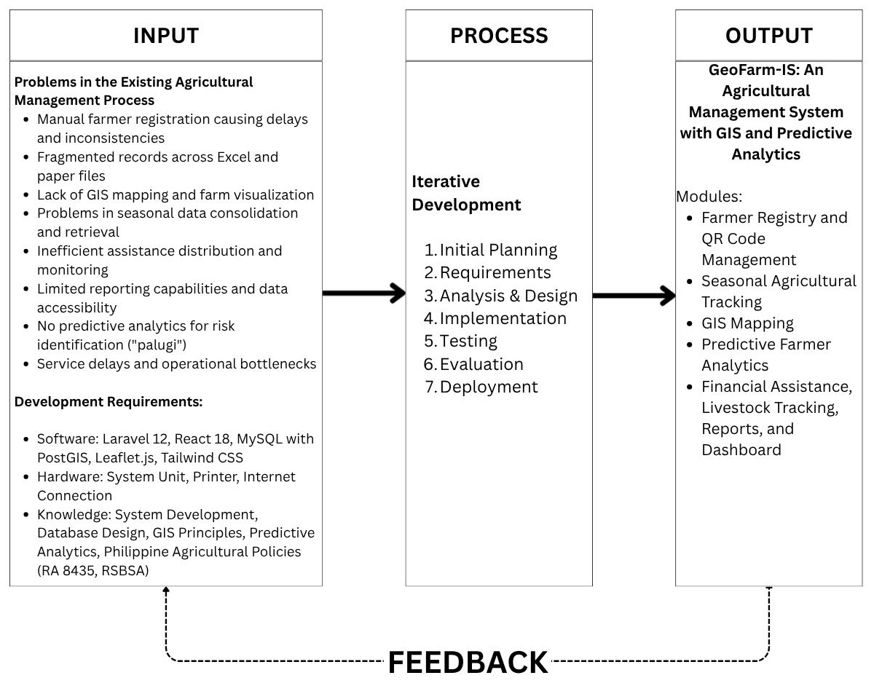
The conceptual framework of GeoFarm-IS is grounded in the Input-Process-Output (IPO) model. It illustrates how the identified agricultural information management needs and development requirements are addressed through an iterative development process to produce GeoFarm-IS and its integrated modules. The framework presents the flow from inputs to development activities and system outputs, with feedback supporting continuous refinement.

Figure 2.1. Conceptual Framework of GeoFarm-IS (Input-Process-Output Model)
The input covers the current problems of the Municipal Agriculture Office, including manual farmer records, fragmented farm parcel and seasonal data, limited GIS mapping, delayed assistance tracking, and difficulty identifying farmers who may be at risk of operating at a loss. It also includes the software, hardware, connectivity, and technical knowledge required to develop the system, such as database design, GIS principles, predictive analytics, agricultural policies, and farmer registration processes.
The process follows the Iterative Development Model, consisting of initial planning, requirements, analysis and design, implementation, testing, evaluation, and deployment. Through these phases, the identified needs and resources are transformed into GeoFarm-IS: An Agricultural Management System with GIS and Predictive Analytics.
The resulting system comprises five integrated modules: Farmer Registry and QR Code Management; Seasonal Agricultural Tracking; GIS Mapping; Predictive Farmer Analytics; and Financial Assistance, Livestock Tracking, Reports, and Dashboard. Together, these modules support centralized record management, spatial monitoring, predictive decision support, assistance and livestock tracking, consolidated reporting, and dashboard-based oversight. Feedback from testing, evaluation, and system use guides further refinement.

Research Paradigm

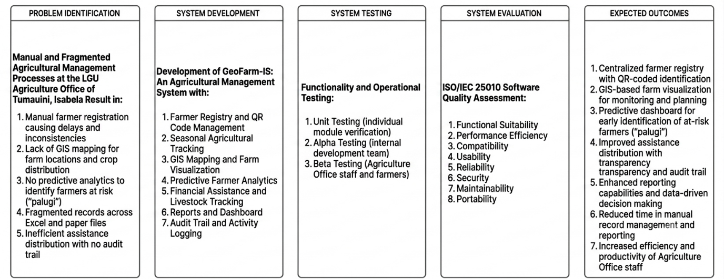
Figure 2-2. Research Paradigm of GeoFarm-IS: An Agricultural Management System
With GIS and Predictive Analytics
The research paradigm illustrates the systematic approach followed in developing and evaluating the GeoFarm-IS system for the Municipal Agriculture Office of Tumauini, Isabela.
The process begins with Problem Identification, which assessed the manual and fragmented agricultural management processes currently in place. The assessment revealed specific challenges including manual farmer registration causing delays and inconsistencies, lack of GIS mapping for farm locations and crop distribution, no predictive analytics to identify farmers at risk ("palugi"), fragmented records across Excel and paper files, and inefficient assistance distribution with no audit trail.
These identified problems guided the System Development phase, where GeoFarm-IS was designed to address each challenge through seven integrated modules. The Farmer Registry and QR Code Management module streamlines farmer registration and provides quick identification. The Seasonal Agricultural Tracking module organizes crop and livestock records. The GIS Mapping and Farm Visualization module enables location-based monitoring and planning. The Predictive Farmer Analytics module identifies farmers at risk of financial loss. The Financial Assistance and Livestock Tracking module ensures transparent aid distribution. The Reports and Dashboard module provides data-driven decision-making support, while the Audit Trail and Activity Logging module ensures accountability.
Following development, the system underwent rigorous System Testing through three stages. Unit Testing verified individual module functionality. Alpha Testing was conducted internally by the development team to identify and resolve technical issues. Beta Testing involved Agriculture Office staff and selected farmers to validate real-world usability and functionality.
The tested system was then evaluated using the ISO/IEC 25010 Software Quality Standard in the System Evaluation phase. The assessment covered eight quality characteristics: Functional Suitability, Performance Efficiency, Compatibility, Usability, Reliability, Security, Maintainability, and Portability.
The Expected Outcomes include centralized farmer registry with QR-coded identification, GIS-based farm visualization for monitoring and planning, predictive dashboard for early identification of at-risk farmers ("palugi"), improved assistance distribution with transparency, enhanced reporting capabilities and data-driven decision making, reduced time in manual record management and reporting, and increased efficiency and productivity of Agriculture Office staff.

System Architecture
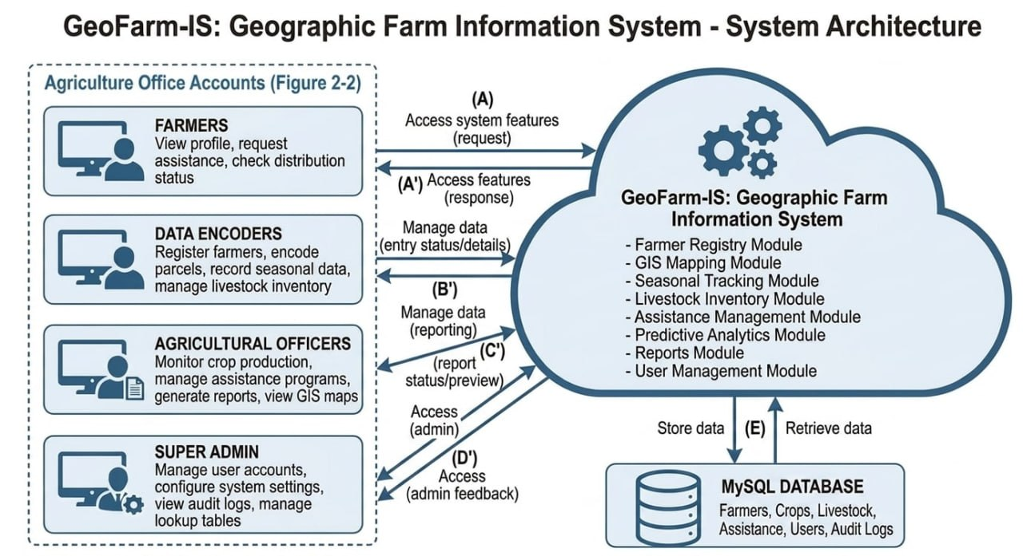
Figure 2.3. System Architecture — GeoFarm-IS
GeoFarm-IS follows a three-tier client-server architecture composed of the Presentation Layer, Business Logic Layer, and Data Layer. This separation supports maintainability, controlled access to data, and the independent development of the user interface, application processes, and database services.
Presentation Layer (Frontend): The user interface is developed using React 18 with Inertia.js as the bridge to the backend and Tailwind CSS for interface styling. Interactive GIS maps are rendered through Leaflet.js, while charts and dashboard visualizations present summarized agricultural records and analytical results.
Business Logic Layer (Backend): Laravel 12 (PHP) handles application logic, including farmer registration, QR code generation, report production, data import and export, authentication, and role-based access control. The predictive analytics module processes historical and seasonal records to classify farmer risk and generate practical recommendations or alerts.
Data Layer (Database): MariaDB 10.4 serves as the relational database and stores farmer profiles, farm parcels, crop seasons, livestock records, assistance data, user access records, and audit logs. Its spatial data types support parcel geometries and geographic queries used by the GIS mapping module, while GeoJSON representations allow parcel boundaries to be displayed through Leaflet.js.
The system may be deployed on a local government server or a managed web server that supports the required PHP, database, and web services. Git and GitHub support version control and collaboration, while the iterative development process organizes implementation, testing, evaluation, deployment, and stakeholder feedback across repeated development cycles.

Context Diagram
The context diagram presents GeoFarm-IS as a single system and summarizes the information exchanged with its external actors. As shown in Figure 2.3, it defines the system boundary without expanding the interactions into lower-level processes.

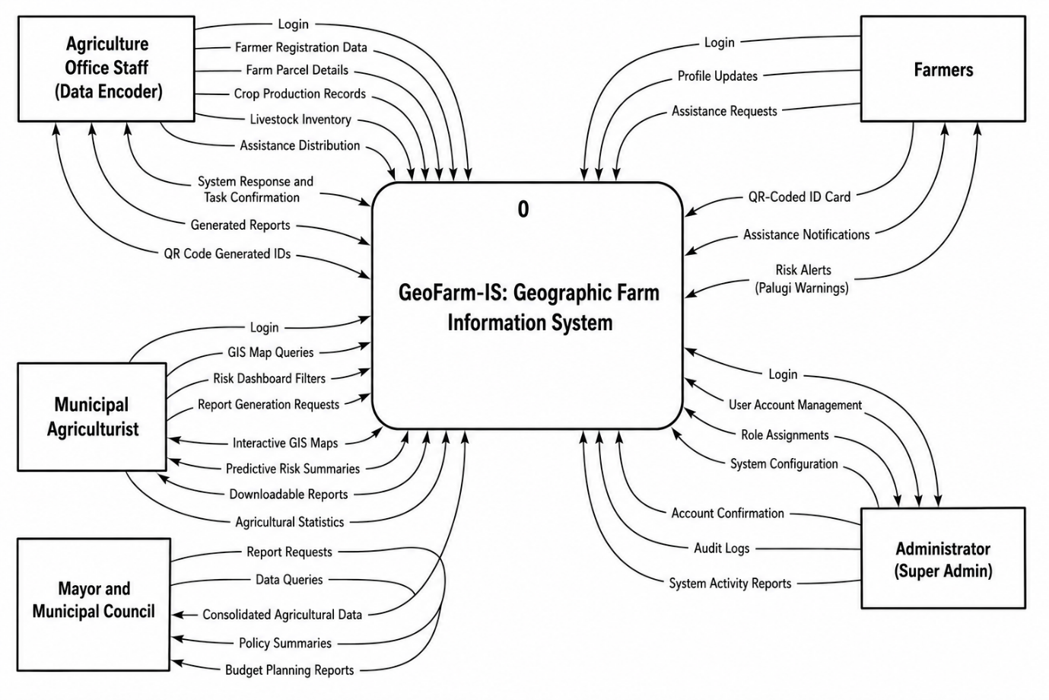
Figure 2.4. Level 0 Context Diagram of GeoFarm-IS
Figure 2.3 shows the external actors that interact with GeoFarm-IS. Agriculture Office personnel submit and maintain farmer profiles, farm parcels, crop and livestock records, and assistance information, and receive confirmations, reports, maps, and QR-coded identification outputs. Farmers access information associated with their profiles, farms, assistance, and risk alerts. The Municipal Agriculturist and local decision-makers review GIS maps, risk summaries, and consolidated reports for planning and program monitoring. The system administrator manages user accounts, roles, permissions, configuration, and audit information. Together, these exchanges define the scope of GeoFarm-IS while the succeeding data flow diagrams describe its internal processes in greater detail.

Data Flow Diagram

GeoFarm-IS Super Admin Data Flow
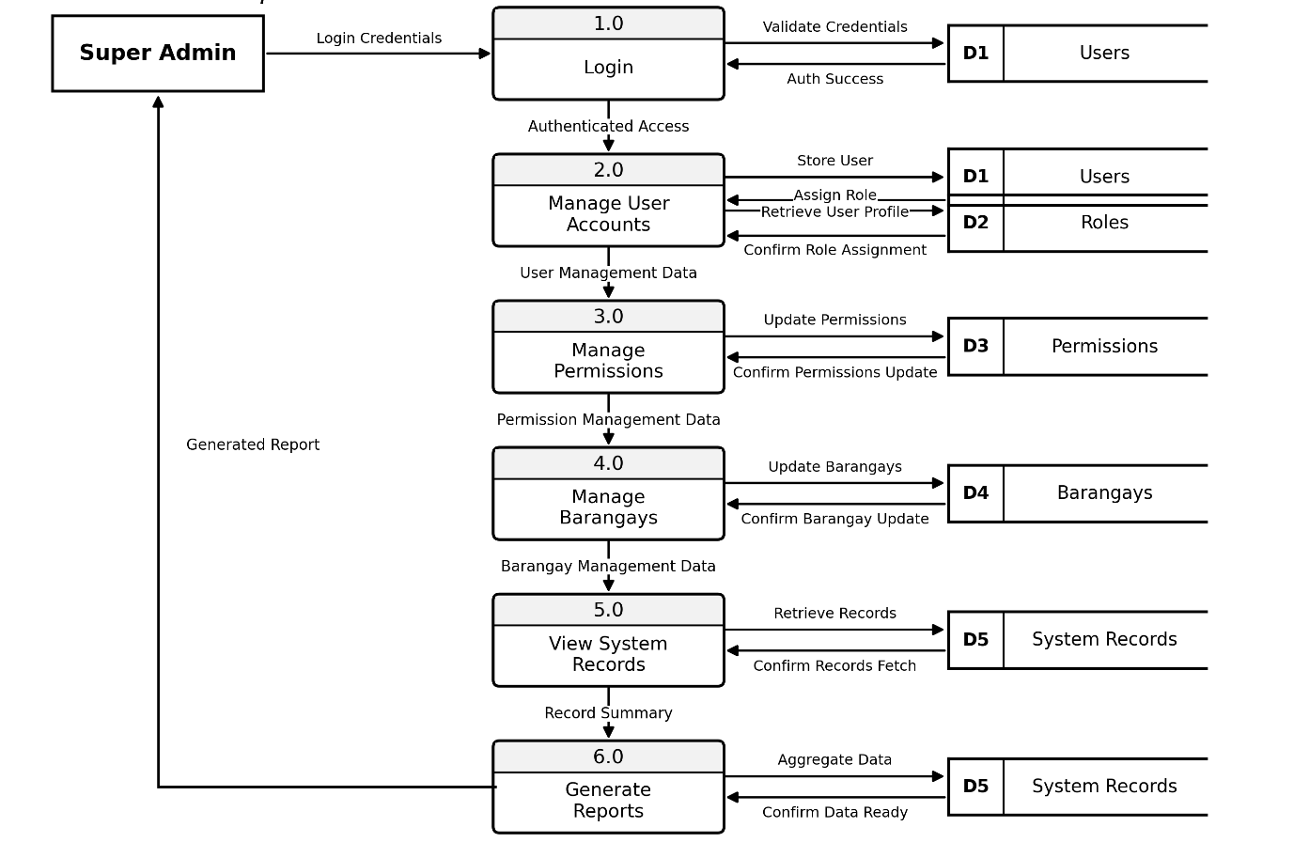
Figure 2.5a. Data Flow Diagram of GeoFarm-IS – Super Admin
The Super Admin begins by entering login credentials, which are validated against the Users data store. Once authenticated, the Super Admin creates and manages user accounts, assigns roles and permissions, maintains barangay records, reviews major system records, and generates summarized reports. Key actions are written to the Audit Logs data store to support accountability and system monitoring.

GeoFarm-IS Admin Data Flow
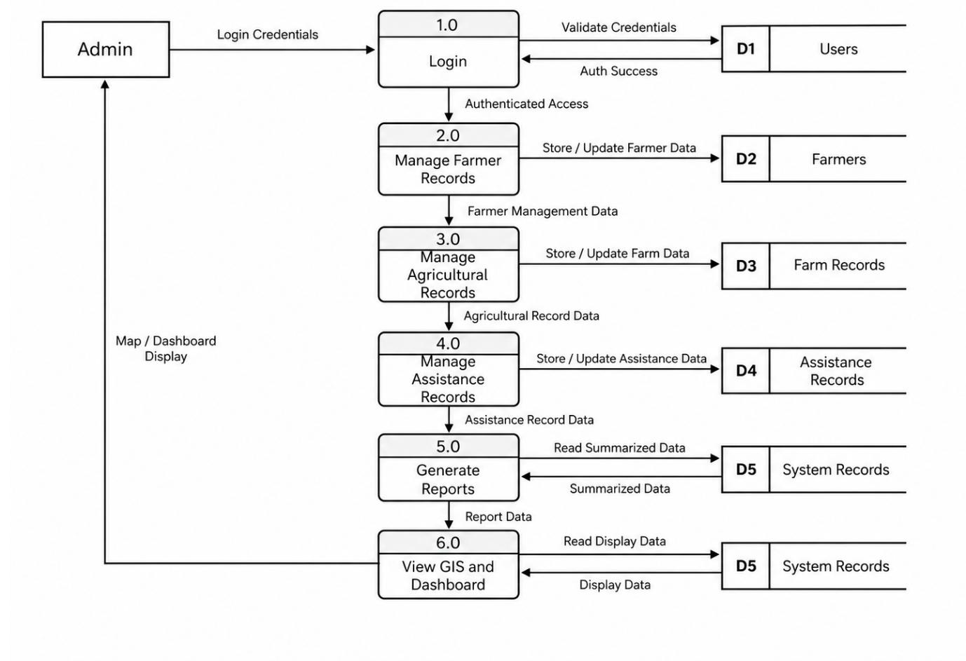
Figure 2.6b. Data Flow Diagram of GeoFarm-IS – Admin
The Admin initiates the process by entering login credentials, which are validated through the Users data store to confirm identity and access permissions. Once authenticated, the Admin can manage farmer registry records, farm parcels, seasonal tracking data, and crop and farm type lookup information. The Admin also manages livestock, tree crops, and fishpond records, as well as assistance programs, assistance distributions, barangay allocations, and Staff/Viewer user accounts. In addition, the Admin can generate reports by retrieving summarized records, view GIS maps by accessing farm parcel data, and monitor the predictive dashboard through system records. All major activities performed by the Admin are recorded in the Audit Logs data store for accountability and monitoring.

GeoFarm-IS Staff Data Flow
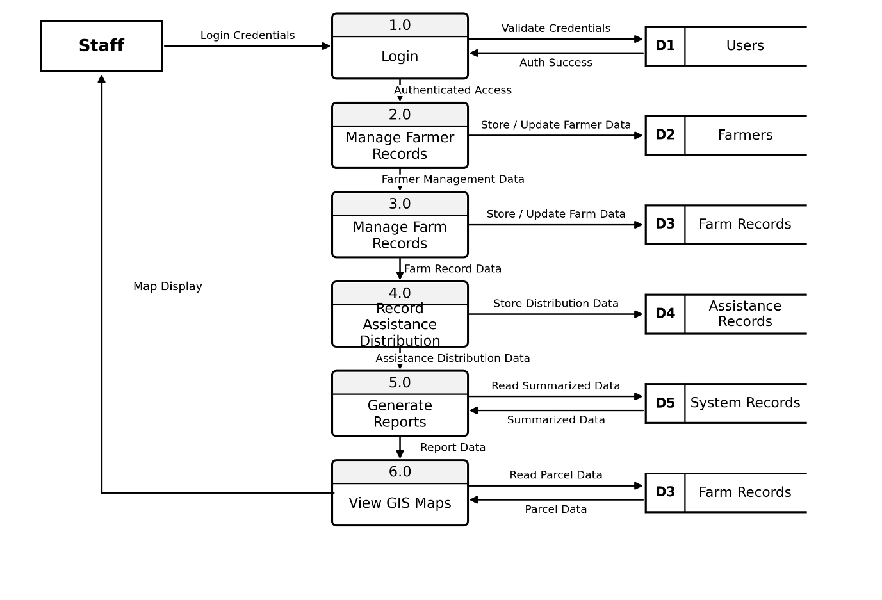
Figure 2.7c. Data Flow Diagram of GeoFarm-IS – Staff
The Staff initiates the process by entering login credentials, which are validated through the Users data store to confirm identity and access permissions. Once authenticated, the Staff can register new farmers, update farmer profiles, manage farm parcel records, and record seasonal crop data. The Staff also records livestock inventory, tree crops, fishpond data, and assistance distribution records. The Staff may generate reports by retrieving summarized system records and may view GIS maps by accessing parcel data from the Farm Parcels data store. All activities performed by the Staff are recorded in the Audit Logs data store to support accountability, monitoring, and proper tracking of system actions.

GeoFarm-IS Municipal Agriculturist / Mayor Data Flow
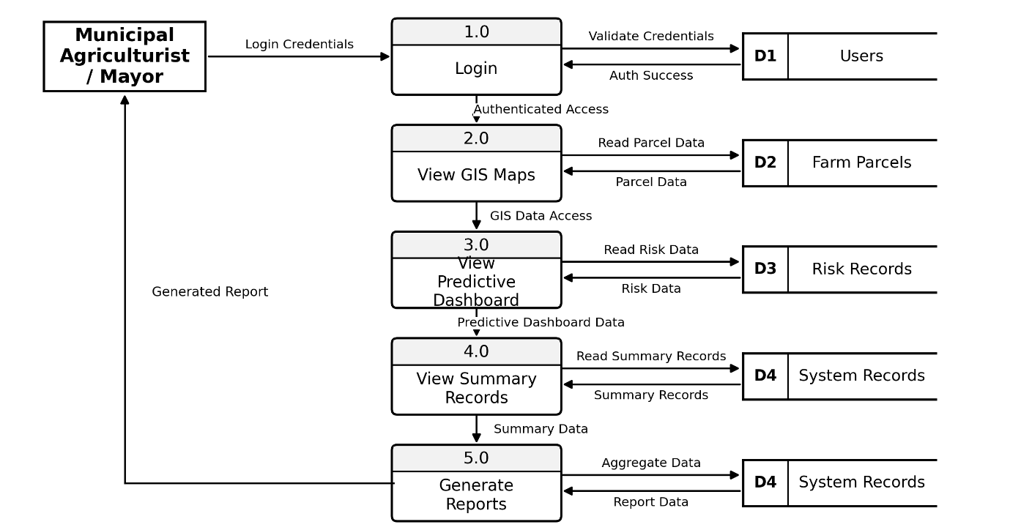
Figure 2.8d. Data Flow Diagram of GeoFarm-IS – Municipal Agriculturist and Mayor
The Municipal Agriculturist / Mayor initiates the process by entering login credentials, which are validated through the Users data store to confirm identity and access permissions. Once authenticated, the Municipal Agriculturist / Mayor can view GIS maps by retrieving parcel data from the Farm Parcels data store and monitor the predictive dashboard by accessing risk-related records. The user can also view summarized system records and generate reports for planning, monitoring, and decision-making. All activities performed by the Municipal Agriculturist / Mayor are recorded in the Audit Logs data store for accountability and monitoring.

GeoFarm-IS Farmer Data Flow
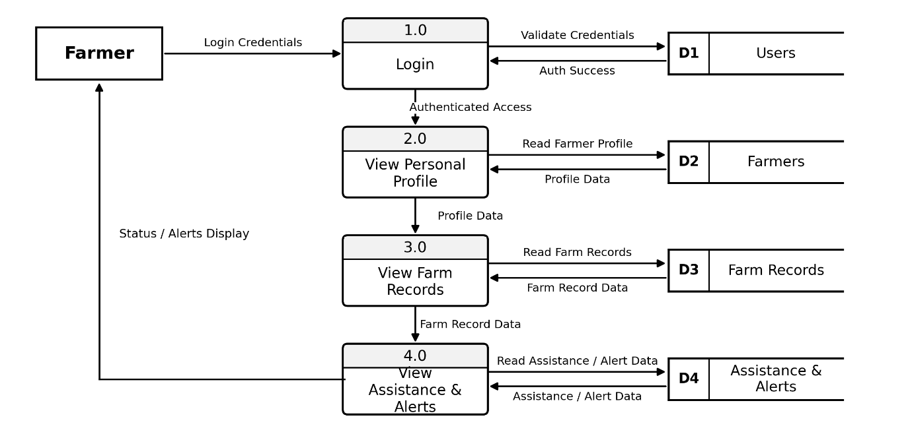
Figure 2.9e. Data Flow Diagram of GeoFarm-IS – Farmer
The Farmer initiates the process by entering login credentials, which are validated through the Users data store to confirm identity and access permissions. Once authenticated, the Farmer can view personal profile information, farm records, and assistance or alert information. These records are retrieved from the corresponding data stores and displayed to the Farmer for reference and monitoring. The Farmer can only view information relevant to their account, while all system interactions are recorded in the Audit Logs data store for tracking and accountability.

GeoFarm-IS Predictive Analytics Data Flow
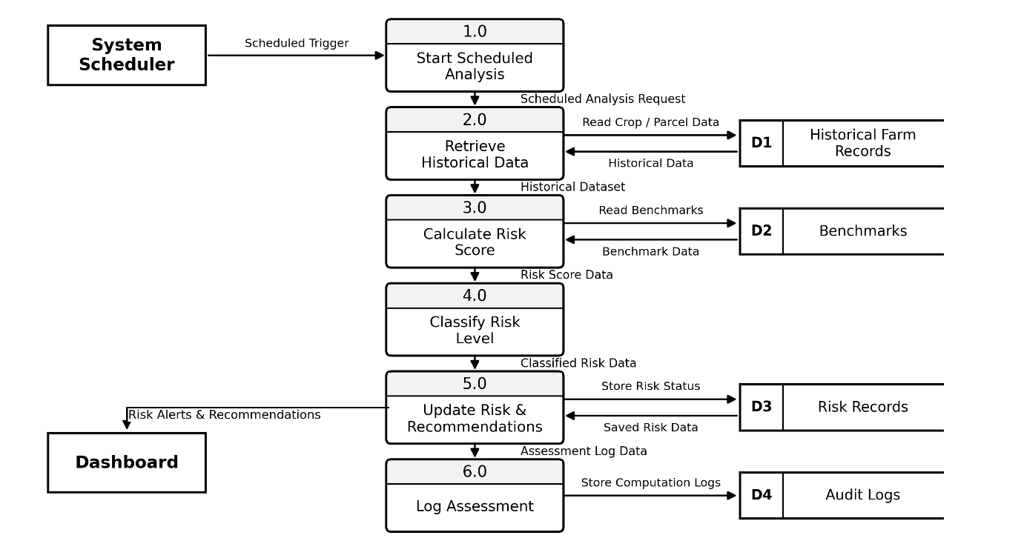
Figure 2.10f. Data Flow Diagram of GeoFarm-IS – Predictive Analytics
The Predictive Analytics module is initiated by the system scheduler. It retrieves historical and seasonal records, including crop-season data, parcel information, yield, inputs, and related farmer records. The module calculates a risk score, compares the available data with defined benchmarks, classifies the farmer’s risk level, updates the recorded risk status, and generates recommendations or alerts for dashboard presentation. Its computations and resulting updates are recorded in the Audit Logs data store for traceability.

Use Case Diagram
The use case diagram identifies the principal user roles and the functions available to each role. Figure 2.5 summarizes these interactions and shows how role-based access separates administrative, operational, farmer-facing, and view-only functions.
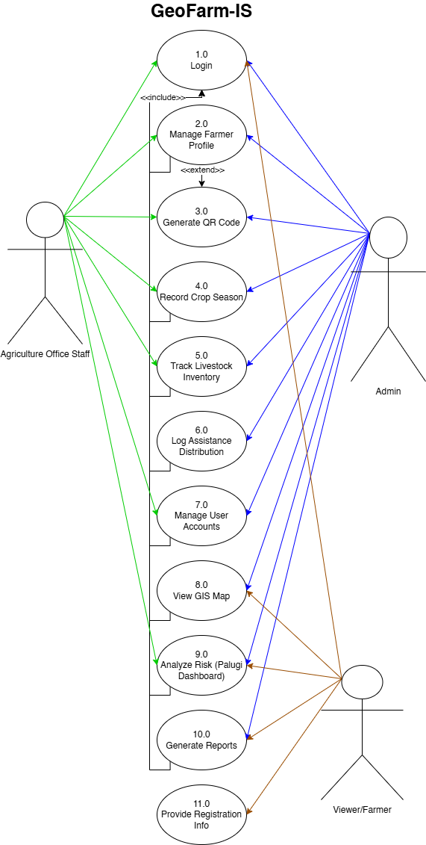

Figure 2.11. Use Case Diagram of GeoFarm-IS
The system applies role-based access according to operational responsibility. The Super Admin manages accounts, roles, permissions, and core configuration. Admin and Agriculture Staff users maintain farmer, farm, production, livestock, assistance, and related operational records, subject to their assigned permissions. Farmers access information associated with their own records and notifications. The Municipal Agriculturist, Mayor, and other authorized viewers review GIS maps, predictive dashboards, and analytical reports for monitoring and decision-making. These permissions limit each actor to the functions and records appropriate to the actor’s role.

Entity Relationship Diagram
The Entity Relationship Diagram (ERD) presents the relational structure of the GeoFarm-IS database. It comprises twenty-eight (28) application tables organized into six functional domains: user and access management; farmer identity, associations, and location; farm parcels and crop seasons; livestock and other agricultural assets; financial assistance; and audit records. The diagram identifies the primary keys, foreign keys, data attributes, and cardinalities that support consistent storage and retrieval of the system's agricultural information.
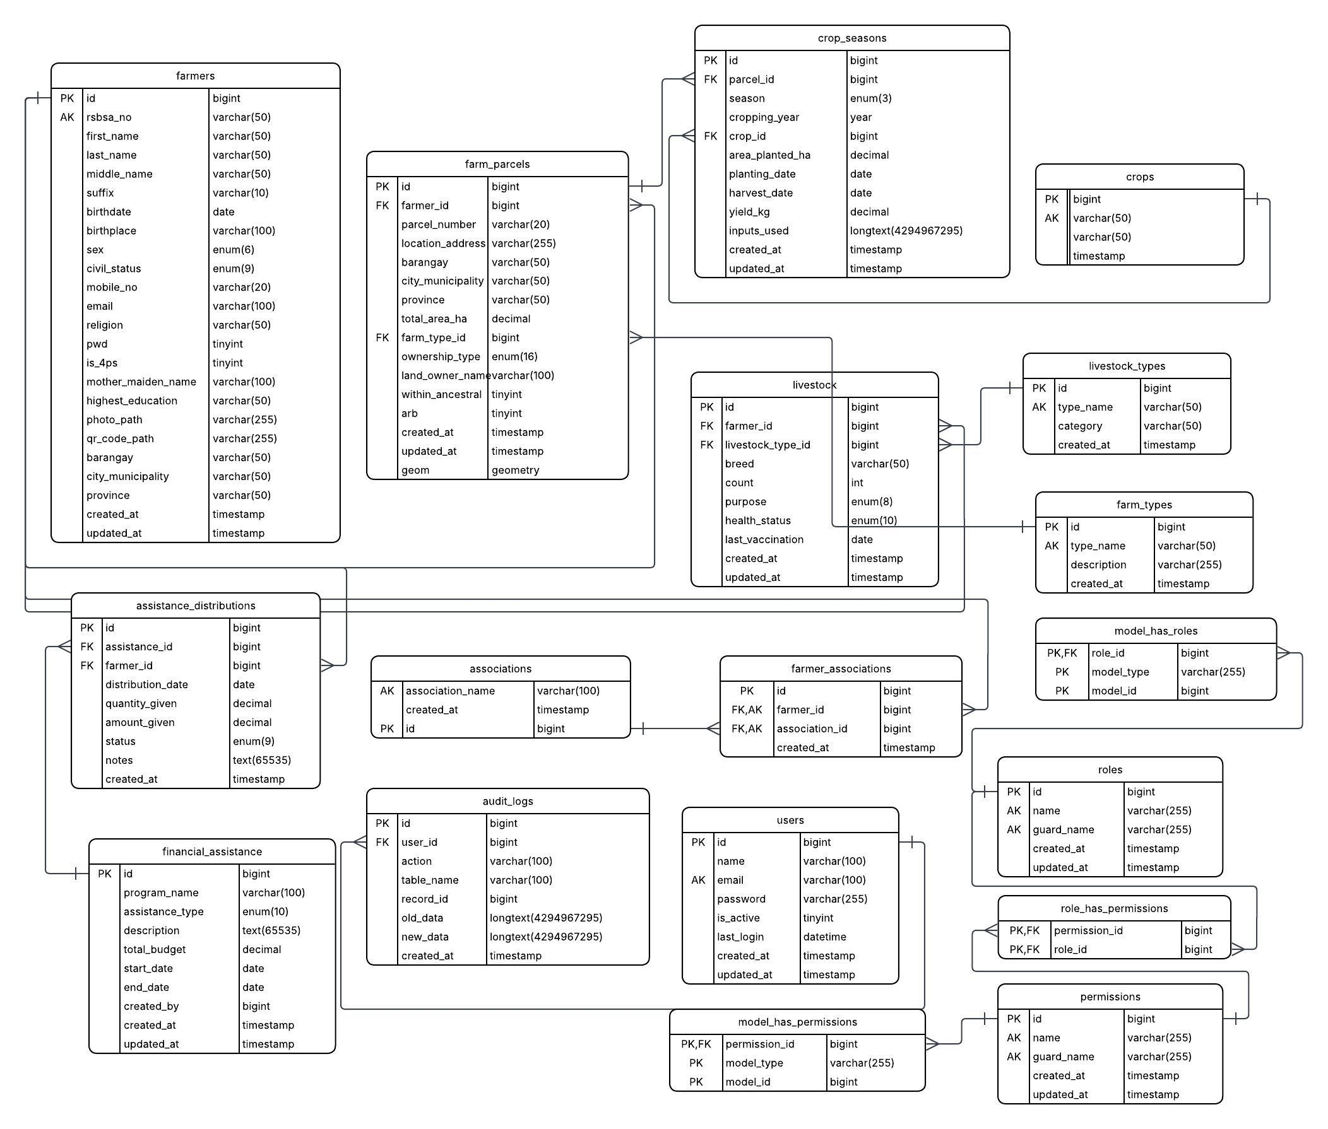
Figure 2.12. GeoFarm-IS Core Database Entity–Relationship Diagram

Core Entities and Relationships:
- users (1) to audit_logs (M): Each audit entry may reference the authenticated user who performed a recorded action through audit_logs.user_id. The ON DELETE SET NULL rule preserves the historical audit record when the associated user account is no longer available.
- roles and permissions (M to M): role_has_permissions resolves the many-to-many relationship between roles and permissions. model_has_roles and model_has_permissions support role and permission assignments to user accounts. Their model_id fields function as logical references to users.id and are represented by dashed connectors.
- farmers, associations, and farmer_associations: A farmer may belong to multiple associations, and an association may have multiple farmers. farmer_associations resolves this many-to-many relationship through enforced farmer_id and association_id foreign keys and prevents duplicate membership pairs through a unique constraint.
- farmers, farm_parcels, farm_types, crop_seasons, and crops: One farmer may have multiple farm parcels, while each parcel may reference one farm type. A parcel may contain multiple crop-season records, and each crop-season record references one crop. These relationships connect farmer identity, mapped land, crop classification, planting dates, harvest dates, area planted, yield, and recorded inputs.
- farmers, livestock, and livestock_types: The general livestock table records multiple livestock entries per farmer and classifies each record through livestock_type_id. This provides a flexible inventory for breed, count, purpose, health status, and vaccination information.
- farmers to specialized agricultural-asset tables (1 to M): large_ruminants, small_ruminants, native_pigs, swine_hybrid, poultry, fishponds, and tree_crops each reference farmers.id. These tables preserve the category-specific counts, species, varieties, pond areas, tree quantities, and production areas required by the Agriculture Office.
- financial_assistance, assistance_distributions, assistance_barangays, farmers, and barangays: One financial-assistance program may have multiple farmer distributions and multiple barangay allocations. assistance_distributions links each program distribution to a farmer, while assistance_barangays links a program to its covered barangays. assistance_types provides the reference classifications used for the assistance categories recorded by the system.
- Enforced and logical dependencies: Solid one-to-many connectors represent the twenty-four (24) foreign-key constraints maintained by the database. Dashed connectors represent application-level references, including financial_assistance.created_by to users.id and the model_id fields of the role and permission assignment tables to users.id. This notation differentiates referential constraints from logical system associations.

The ERD presents the primary keys, unique keys, data types, and dependency rules of the database. farm_parcels.geom stores the spatial geometry used for mapping, while geojson_data stores its serialized map representation. crop_seasons.inputs_used records the agricultural inputs applied during a cropping period. Cascade and set-null actions maintain referential consistency according to the purpose of each relationship.

Database Schema
The GeoFarm-IS database schema is implemented in MariaDB 10.4 and comprises twenty-eight (28) application tables. Tables 2-1 through 2-28 describe the entities presented in Figure 2.6, including their attributes, data types, keys, and functional roles. Together, these tables support user access, farmer profiling, farm mapping, crop and livestock records, assistance management, and system auditing.

Tables 2-1 to 2-28. GeoFarm-IS Database Schema
Table 2-1. Table for users Information
Table: users
Field Name | Data Type | Description
id | BIGINT UNSIGNED PK | Auto-increment primary key
name | VARCHAR(100) | Full display name of the user
email | VARCHAR(100) UNIQUE | Login email address
password | VARCHAR(255) | Bcrypt-hashed password
is_active | TINYINT(1) | Account active flag (1=active)
last_login | DATETIME | Timestamp of last successful login
created_at | TIMESTAMP | Record creation timestamp
updated_at | TIMESTAMP | Last update timestamp

Table 2-1 presents the users table, which stores authentication credentials and account metadata for all system users. User roles are managed separately via the RBAC pivot tables.
Table 2-2. Table for farmers Information
Table: farmers
Field Name | Data Type | Description
id | BIGINT UNSIGNED PK | Auto-increment primary key
rsbsa_no | VARCHAR(50) | RSBSA registration number
first_name | VARCHAR(50) | Farmer first name
last_name | VARCHAR(50) | Farmer last name
middle_name | VARCHAR(50) | Middle name
suffix | VARCHAR(10) | Name suffix (Jr., Sr., etc.)
birthdate | DATE | Date of birth
birthplace | VARCHAR(100) | Place of birth
sex | ENUM('Male','Female') | Biological sex
civil_status | ENUM('Single','Married',...) | Civil status
mobile_no | VARCHAR(20) | Mobile phone number
email | VARCHAR(100) | Email address
religion | VARCHAR(50) | Religion
pwd | TINYINT(1) | Person with disability flag
is_indigenous | TINYINT(1) | Indigenous Peoples flag
is_4ps | TINYINT(1) | 4Ps beneficiary flag
organization_name | VARCHAR(100) | Farmer organization/coop
risk_status | ENUM('low','medium','high','critical') | Current palugi risk level
risk_updated_at | TIMESTAMP | When risk_status was last set
highest_education | VARCHAR(50) | Highest educational attainment
photo_path | VARCHAR(255) | Path to farmer photo
qr_code_path | VARCHAR(255) | Path to generated QR code image
barangay | VARCHAR(50) | Barangay of residence
city_municipality | VARCHAR(50) | City/municipality
province | VARCHAR(50) | Province
created_at | TIMESTAMP | Record creation timestamp
updated_at | TIMESTAMP | Last update timestamp

Table 2-2 presents the farmers table, the central entity of GeoFarm-IS. It stores comprehensive personal information, RSBSA registration number, demographic details, and a computed risk_status field that is updated by the predictive analytics module to flag farmers at risk of palugi.
Table 2-3. Table for farmer_associations Information
Table: farmer_associations
Field Name | Data Type | Description
id | BIGINT UNSIGNED PK | Auto-increment primary key
farmer_id | BIGINT UNSIGNED FK | References farmers.id
association_id | BIGINT UNSIGNED FK | References associations.id
created_at | TIMESTAMP | Record creation timestamp

Table 2-3 presents the farmer_associations pivot table, which creates a many-to-many relationship between farmers and cooperatives or irrigators associations.
Table 2-4. Table for associations Information
Table: associations
Field Name | Data Type | Description
id | BIGINT UNSIGNED PK | Auto-increment primary key
association_name | VARCHAR(100) | Name of farmers cooperative or association
created_at | TIMESTAMP | Record creation timestamp

Table 2-4 presents the associations lookup table, which stores the names of farmer cooperatives and irrigators associations operating in Tumauini.
Table 2-5. Table for farm_parcels Information
Table: farm_parcels
Field Name | Data Type | Description
id | BIGINT UNSIGNED PK | Auto-increment primary key
farmer_id | BIGINT UNSIGNED FK | References farmers.id
parcel_number | VARCHAR(20) | Parcel identifier code
location_address | VARCHAR(255) | Street / sitio address
barangay | VARCHAR(50) | Barangay where parcel is located
city_municipality | VARCHAR(50) | City or municipality
province | VARCHAR(50) | Province
total_area_ha | DECIMAL(10,2) | Total parcel area in hectares
farm_type_id | BIGINT UNSIGNED FK | References farm_types.id
ownership_type | ENUM('Registered Owner','Lessee','Tenant',...) | Land ownership classification
land_owner_name | VARCHAR(100) | Name of registered land owner
within_ancestral | TINYINT(1) | Inside ancestral domain flag
arb | TINYINT(1) | Agrarian reform beneficiary flag
geom | GEOMETRY | Spatial geometry (MariaDB spatial data)
geojson_data | TEXT | GeoJSON string for Leaflet.js rendering
created_at | TIMESTAMP | Record creation timestamp
updated_at | TIMESTAMP | Last update timestamp

Table 2-5 presents the farm_parcels table, which stores land parcel data for each farmer. The geom column stores spatial boundary polygons used by the GIS Mapping module, while geojson_data stores the GeoJSON representation for Leaflet.js rendering.
Table 2-6. Table for farm_types Information
Table: farm_types
Field Name | Data Type | Description
id | BIGINT UNSIGNED PK | Auto-increment primary key
type_name | VARCHAR(50) | Farm type name (Irrigated, Rainfed, Upland, Lowland, Aquaculture)
description | VARCHAR(255) | Description of farm type
created_at | TIMESTAMP | Record creation timestamp

Table 2-6 presents the farm_types lookup table, providing standardized classification for parcels as Irrigated, Rainfed, Upland, Lowland, or Aquaculture.
Table 2-7. Table for crops Information
Table: crops
Field Name | Data Type | Description
id | BIGINT UNSIGNED PK | Auto-increment primary key
crop_name | VARCHAR(50) | Crop name (Rice, Corn, Tomato, etc.)
category | VARCHAR(50) | Crop category (Cereal, Vegetable, Fruit, etc.)
seeding_rate_kg_per_ha | DECIMAL(8,2) | Standard seeding rate in kg/ha
fertilizer_bags_per_ha | DECIMAL(8,2) | Standard fertilizer requirement
created_at | TIMESTAMP | Record creation timestamp

Table 2-7 presents the crops lookup table, which defines crop types with recommended seeding and fertilizer rates to support input planning for crop season records.
Table 2-8. Table for crop_seasons Information
Table: crop_seasons
Field Name | Data Type | Description
id | BIGINT UNSIGNED PK | Auto-increment primary key
parcel_id | BIGINT UNSIGNED FK | References farm_parcels.id
season | ENUM('dry','wet') | Cropping season
cropping_year | YEAR(4) | Calendar year of cropping
crop_id | BIGINT UNSIGNED FK | References crops.id
area_planted_ha | DECIMAL(10,2) | Area planted in hectares
planting_date | DATE | Date of planting
harvest_date | DATE | Date of harvest
yield_kg | DECIMAL(10,2) | Total yield in kilograms
inputs_used | JSON | Agricultural inputs used (fertilizer, pesticide, etc.)
created_at | TIMESTAMP | Record creation timestamp
updated_at | TIMESTAMP | Last update timestamp

Table 2-8 presents the crop_seasons table, which records agricultural activity per parcel per season. The inputs_used JSON column captures fertilizer, pesticide, and other input details in a flexible format.
Table 2-9. Table for livestock Information
Table: livestock
Field Name | Data Type | Description
id | BIGINT UNSIGNED PK | Auto-increment primary key
farmer_id | BIGINT UNSIGNED FK | References farmers.id
livestock_type_id | BIGINT UNSIGNED FK | References livestock_types.id
breed | VARCHAR(50) | Animal breed name
count | INT | Number of animals
purpose | ENUM('Dairy','Meat','Draft','Breeding','Pet') | Raising purpose
health_status | ENUM('Healthy','Sick','Treated','Vaccinated') | Current health status
last_vaccination | DATE | Date of last vaccination
created_at | TIMESTAMP | Record creation timestamp
updated_at | TIMESTAMP | Last update timestamp

Table 2-9 presents the general livestock table for flexible inventory tracking across multiple livestock type categories, linked to livestock_types.
Table 2-10. Table for livestock_types Information
Table: livestock_types
Field Name | Data Type | Description
id | BIGINT UNSIGNED PK | Auto-increment primary key
type_name | VARCHAR(50) | Livestock type name (Cattle, Carabao, Goat, etc.)
category | VARCHAR(50) | Category (Large ruminant, Small ruminant, Poultry, etc.)
created_at | TIMESTAMP | Record creation timestamp

Table 2-10 presents the livestock_types lookup table, providing standardized classification for cattle, carabao, goat, sheep, and other animal categories.
Table 2-11. Table for large_ruminants Information
Table: large_ruminants
Field Name | Data Type | Description
id | BIGINT UNSIGNED PK | Auto-increment primary key
farmer_id | BIGINT UNSIGNED FK | References farmers.id
animal_type | ENUM('Cattle','Carabao') | Type of large ruminant
male_count | INT | Number of male heads
female_count | INT | Number of female heads
total_heads | INT GENERATED STORED | Computed sum of male + female heads
is_large_raiser | TINYINT(1) | Auto-set when total heads exceeds 20
created_at | TIMESTAMP | Record creation timestamp
updated_at | TIMESTAMP | Last update timestamp

Table 2-11 presents the large_ruminants table. The total_heads column is a computed GENERATED column, automatically summing male_count and female_count to eliminate manual calculation errors.
Table 2-12. Table for small_ruminants Information
Table: small_ruminants
Field Name | Data Type | Description
id | BIGINT UNSIGNED PK | Auto-increment primary key
farmer_id | BIGINT UNSIGNED FK | References farmers.id
animal_type | ENUM('Goat','Sheep') | Type of small ruminant
male_count | INT | Number of male heads
female_count | INT | Number of female heads
total_heads | INT GENERATED STORED | Computed sum of male + female heads
is_large_raiser | TINYINT(1) | Auto-set when total heads exceeds threshold
created_at | TIMESTAMP | Record creation timestamp
updated_at | TIMESTAMP | Last update timestamp

Table 2-12 presents the small_ruminants table for goat and sheep inventory per farmer, with the same generated total_heads pattern.
Table 2-13. Table for native_pigs Information
Table: native_pigs
Field Name | Data Type | Description
id | BIGINT UNSIGNED PK | Auto-increment primary key
farmer_id | BIGINT UNSIGNED FK | References farmers.id
male_count | INT | Number of male heads
female_count | INT | Number of female heads
total_heads | INT GENERATED STORED | Computed sum of male + female heads
is_large_raiser | TINYINT(1) | Auto-set when total heads exceeds threshold
created_at | TIMESTAMP | Record creation timestamp
updated_at | TIMESTAMP | Last update timestamp

Table 2-13 presents the native_pigs table for indigenous pig breed inventory per farmer.
Table 2-14. Table for swine_hybrid Information
Table: swine_hybrid
Field Name | Data Type | Description
id | BIGINT UNSIGNED PK | Auto-increment primary key
farmer_id | BIGINT UNSIGNED FK | References farmers.id
variety | ENUM('White','Brown') | Hybrid variety
male_count | INT | Number of male heads
female_count | INT | Number of female heads
total_heads | INT GENERATED STORED | Computed sum of male + female heads
is_large_raiser | TINYINT(1) | Auto-set when total heads exceeds threshold
created_at | TIMESTAMP | Record creation timestamp
updated_at | TIMESTAMP | Last update timestamp

Table 2-14 presents the swine_hybrid table for commercial hybrid pig inventory per farmer, differentiated by White and Brown variety.
Table 2-15. Table for poultry Information
Table: poultry
Field Name | Data Type | Description
id | BIGINT UNSIGNED PK | Auto-increment primary key
farmer_id | BIGINT UNSIGNED FK | References farmers.id
bird_type | ENUM('Chicken','Ducks','Goose','Turkey') | Type of poultry bird
male_count | INT | Number of male birds
female_count | INT | Number of female birds
total_heads | INT GENERATED STORED | Computed sum of male + female heads
is_large_raiser | TINYINT(1) | Auto-set when total heads exceeds threshold
created_at | TIMESTAMP | Record creation timestamp
updated_at | TIMESTAMP | Last update timestamp

Table 2-15 presents the poultry table, tracking chicken, duck, goose, and turkey inventories with sex-disaggregated head counts.
Table 2-16. Table for fishponds Information
Table: fishponds
Field Name | Data Type | Description
id | BIGINT UNSIGNED PK | Auto-increment primary key
farmer_id | BIGINT UNSIGNED FK | References farmers.id
species | ENUM('Tilapia','Hito') | Fish species raised
area_hectares | DECIMAL(8,2) | Pond area in hectares
created_at | TIMESTAMP | Record creation timestamp
updated_at | TIMESTAMP | Last update timestamp

Table 2-16 presents the fishponds table for aquaculture inventory, recording species (Tilapia or Hito) and pond area per farmer.
Table 2-17. Table for tree_crops Information
Table: tree_crops
Field Name | Data Type | Description
id | BIGINT UNSIGNED PK | Auto-increment primary key
farmer_id | BIGINT UNSIGNED FK | References farmers.id
crop_type | ENUM('Mango','Banana','Cacao','Pineapple') | Type of tree/perennial crop
quantity | INT | Number of trees (for Mango, Banana, Cacao)
area_hectares | DECIMAL(8,2) | Area in hectares (for Pineapple)
created_at | TIMESTAMP | Record creation timestamp
updated_at | TIMESTAMP | Last update timestamp

Table 2-17 presents the tree_crops table for perennial crop inventory, supporting Mango, Banana, Cacao (tracked by number of trees) and Pineapple (tracked by area in hectares).
Table 2-18. Table for financial_assistance Information
Table: financial_assistance
Field Name | Data Type | Description
id | BIGINT UNSIGNED PK | Auto-increment primary key
program_name | VARCHAR(100) | Name of the assistance program
assistance_type | ENUM('cash','fertilizer','seed','vaccine',...) | Type of assistance provided
description | TEXT | Program description and details
total_budget | DECIMAL(12,2) | Total allocated budget (PHP)
start_date | DATE | Program start date
end_date | DATE | Program end date
status | ENUM('draft','active','completed','cancelled') | Current program status
created_by | BIGINT UNSIGNED FK | References users.id (Admin who created)
created_at | TIMESTAMP | Record creation timestamp
updated_at | TIMESTAMP | Last update timestamp

Table 2-18 presents the financial_assistance table, which defines each assistance program with its type, budget, date range, and status lifecycle (draft, active, completed, cancelled).
Table 2-19. Table for assistance_types Information
Table: assistance_types
Field Name | Data Type | Description
id | BIGINT UNSIGNED PK | Auto-increment primary key
category | VARCHAR(100) | Category of assistance
type_name | VARCHAR(100) | Specific type name
description | TEXT | Type description
distribution_type | ENUM('financial','material','training','service') | How assistance is delivered
created_at | TIMESTAMP | Record creation timestamp

Table 2-19 presents the assistance_types lookup table, classifying assistance by delivery modality as financial, material, training, or service.
Table 2-20. Table for assistance_distributions Information
Table: assistance_distributions
Field Name | Data Type | Description
id | BIGINT UNSIGNED PK | Auto-increment primary key
assistance_id | BIGINT UNSIGNED FK | References financial_assistance.id
farmer_id | BIGINT UNSIGNED FK | References farmers.id
distribution_date | DATE | Date assistance was distributed
quantity_given | DECIMAL(10,2) | Quantity of material assistance given
amount_given | DECIMAL(10,2) | Monetary value of assistance (PHP)
status | ENUM('pending','claimed','forfeited') | Claim status of distribution
notes | TEXT | Additional notes or remarks
created_at | TIMESTAMP | Record creation timestamp

Table 2-20 presents the assistance_distributions table, which records individual farmer distributions from each program with quantity, amount, and claim status tracking.
Table 2-21. Table for assistance_barangays Information
Table: assistance_barangays
Field Name | Data Type | Description
id | BIGINT UNSIGNED PK | Auto-increment primary key
assistance_id | BIGINT UNSIGNED FK | References financial_assistance.id
barangay_id | BIGINT UNSIGNED FK | References barangays.id
created_at | TIMESTAMP | Record creation timestamp
updated_at | TIMESTAMP | Last update timestamp

Table 2-21 presents the assistance_barangays pivot table, enabling barangay-level allocation of assistance programs where distribution is area-wide rather than individual.
Table 2-22. Table for barangays Information
Table: barangays
Field Name | Data Type | Description
id | BIGINT UNSIGNED PK | Auto-increment primary key
name | VARCHAR(100) | Barangay name
municipality | VARCHAR(100) | Municipality (default: Tumauini)
province | VARCHAR(100) | Province (default: Isabela)
is_active | TINYINT(1) | Active flag for barangay record
created_at | TIMESTAMP | Record creation timestamp
updated_at | TIMESTAMP | Last update timestamp

Table 2-22 presents the barangays lookup table, pre-seeded with all 46 official barangays of Tumauini, Isabela.
Table 2-23. Table for audit_logs Information
Table: audit_logs
Field Name | Data Type | Description
id | BIGINT UNSIGNED PK | Auto-increment primary key
user_id | BIGINT UNSIGNED FK | References users.id (nullable for system actions)
action | VARCHAR(100) | Action performed (CREATE, UPDATE, DELETE, LOGIN, etc.)
table_name | VARCHAR(100) | Database table affected by the action
record_id | BIGINT UNSIGNED | Primary key of the affected record
old_data | JSON | Previous field values before change
new_data | JSON | New field values after change
created_at | TIMESTAMP | Timestamp of action

Table 2-23 presents the audit_logs table, which records every significant data modification in the system. Old and new field values are stored in JSON format, creating a complete before-and-after trail for accountability and compliance.
Table 2-24. Table for roles Information
Table: roles
Field Name | Data Type | Description
id | BIGINT UNSIGNED PK | Auto-increment primary key
name | VARCHAR(255) | Role name (Super Admin, Admin, Staff, Viewer)
guard_name | VARCHAR(255) | Authentication guard (default: web)
created_at | TIMESTAMP | Record creation timestamp
updated_at | TIMESTAMP | Last update timestamp
Table 2-24 presents the roles table used by Spatie Laravel Permission for role-based access control. System roles include Super Admin, Admin, Staff, and Viewer.
Table 2-25. Table for permissions Information
Table: permissions
Field Name | Data Type | Description
id | BIGINT UNSIGNED PK | Auto-increment primary key
name | VARCHAR(255) | Permission name (e.g., view farmers, edit farmers)
guard_name | VARCHAR(255) | Authentication guard (default: web)
created_at | TIMESTAMP | Record creation timestamp
updated_at | TIMESTAMP | Last update timestamp

Table 2-25 presents the permissions table, defining granular action-level access rights (e.g., view farmers, edit farmers, delete farmers) assignable to roles or individual users.
Table 2-26. Table for model_has_roles Information
Table: model_has_roles
Field Name | Data Type | Description
role_id | BIGINT UNSIGNED FK | References roles.id
model_type | VARCHAR(255) | Eloquent model class (App\Models\User)
model_id | BIGINT UNSIGNED FK | Primary key of the model instance (user id)

Table 2-26 presents the model_has_roles pivot table, assigning one or more roles to each user.
Table 2-27. Table for model_has_permissions Information
Table: model_has_permissions
Field Name | Data Type | Description
permission_id | BIGINT UNSIGNED FK | References permissions.id
model_type | VARCHAR(255) | Eloquent model class (App\Models\User)
model_id | BIGINT UNSIGNED FK | Primary key of the model instance (user id)

Table 2-27 presents the model_has_permissions pivot table, allowing direct permission grants to individual users beyond their role-level access.
Table 2-28. Table for role_has_permissions Information
Table: role_has_permissions
Field Name | Data Type | Description
permission_id | BIGINT UNSIGNED FK | References permissions.id
role_id | BIGINT UNSIGNED FK | References roles.id

Table 2-28 presents the role_has_permissions pivot table, defining which permissions are included in each role.

Timestamp columns such as created_at and updated_at are maintained through the Laravel Eloquent ORM and the database configuration. Generated total_heads columns in the livestock sub-tables reduce repeated manual calculations. The farm_parcels table stores parcel boundaries in a spatial geometry field and retains a GeoJSON representation for Leaflet.js rendering, allowing the mapping module to use both database-level spatial data and web-compatible map features.

GANTT Chart
 | Capstone Project Activiti |  |  | es
Legend: | Project Start: February 2025 |  |  | Project End:
Legend: | To Do: |  | Ongoing: |  | Done:
Table 2-29. Activities for the Month of February
Tasks: |  | Week 1 |  |  |  |  | Week 2 |  |  |  |  | Week 3 |  |  |  |  |  | Week 4
Tasks: | M | T | W | Th | F | M | T | W | Th | F | M | T | W | Th | F | M | T | W | Th | F

Topic Selection
Table 2-30. Activities for the Month of March
Tasks: | Week 1 |  |  |  |  | Week 2 |  |  |  |  |  | Week 3 |  |  |  |  | Week 4
Tasks: | M | T | W | Th | F | M | T | W | Th | F | M | T | W | Th | F | M | T | W | Th | F

Topic Selection

Title

Proposal

Introduction

Objectives of the study

Scope and Limitation

Significance of the Study

Related

Literature and Studies

Definition of Terms

Conceptual Framework

System

Architecture

Context Diagram

Data Flow Diagram

Entity

Relationship Diagram

Database Schema

GANTT

Chart

Software

Developme

nt

Methodolog

y

Respondent s of the

Study

Sampling Technique

Statistical

Treatment
Table 2-31. Activities for the Month of April
Tasks: |  | Week 1 |  |  |  |  | Week 2 |  |  |  |  | Week 3 |  |  |  |  | Week 4
Tasks: | M | T | W | Th | F | M | T | W | Th | F | M | T | W | Th | F | M | T | W | Th | F

Software

Developme

nt

Methodolog

y

Respondent s of the

Study

Sampling Technique

Statistical

Treatment

Preliminary Defense
Table 2-32. Activities for the Month of May
Tasks: |  | Week 1 |  |  |  |  | Week 2 |  |  |  |  | Week 3 |  |  |  |  | Week 4
Tasks: | M | T | W | Th | F | M | T | W | Th | F | M | T | W | Th | F | M | T | W | Th | F

Apply

Recommen dations

System

Developme

nt

Secondary Defense
Table 2-33. Activities for the Month of June
Tasks: |  | Week 1 |  |  |  |  | Week 2 |  |  |  |  | Week 3 |  |  |  |  | Week 4
Tasks: | M | T | W | Th | F | M | T | W | Th | F | M | T | W | Th | F | M | T | W | Th | F

Apply

Recommen dations

System

Developme

nt
Table 2-34. Activities for the Month of July
Tasks: |  | Week 1 |  |  |  |  | Week 2 |  |  |  |  | Week 3 |  |  |  |  | Week 4
Tasks: | M | T | W | Th | F | M | T | W | Th | F | M | T | W | Th | F | M | T | W | Th | F

Apply

Recommen dations

System

Developme

nt
Table 2-35. Activities for the Month of August
Tasks: |  | Week 1 |  |  |  |  | Week 2 |  |  |  |  | Week 3 |  |  |  |  | Week 4
Tasks: | M | T | W | Th | F | M | T | W | Th | F | M | T | W | Th | F | M | T | W | Th | F

Apply

Recommen dations

System

Developme

nt
Table 2-36. Activities for the Month of September
Tasks: |  | Week 1 |  |  |  |  | Week 2 |  |  |  |  | Week 3 |  |  |  |  | Week 4
Tasks: | M | T | W | Th | F | M | T | W | Th | F | M | T | W | Th | F | M | T | W | Th | F

Apply

Recommen dations

System

Developme

nt
Table 2-37. Activities for the Month of October
Tasks: |  | Week 1 |  |  |  |  | Week 2 |  |  |  |  | Week 3 |  |  |  |  | Week 4
Tasks: | M | T | W | Th | F | M | T | W | Th | F | M | T | W | Th | F | M | T | W | Th | F

Apply

Recommen dations

System

Developme

nt
Table 2-38. Activities for the Month of November
Tasks: |  | Week 1 |  |  |  |  | Week 2 |  |  |  |  | Week 3 |  |  |  |  | Week 4
Tasks: | M | T | W | Th | F | M | T | W | Th | F | M | T | W | Th | F | M | T | W | Th | F

Apply

Recommen dations

System

Developme

nt
Table 2-39. Activities for the Month of December
Tasks: |  | Week 1 |  |  |  |  | Week 2 |  |  |  |  | Week 3 |  |  |  |  | Week 4
Tasks: | M | T | W | Th | F | M | T | W | Th | F | M | T | W | Th | F | M | T | W | Th | F

Final

Defense

Apply

Recommen dations

CHAPTER III
METHODOLOGY
The researchers will use the Iterative Development Model in developing the web-based Geographic Farm Information System (GeoFarm-IS) for the Municipal Agriculture Office. This approach allows the system to be developed through repeated cycles where each iteration builds upon the previous one, enabling continuous improvement based on testing results and stakeholder feedback.
Software Development Methodology
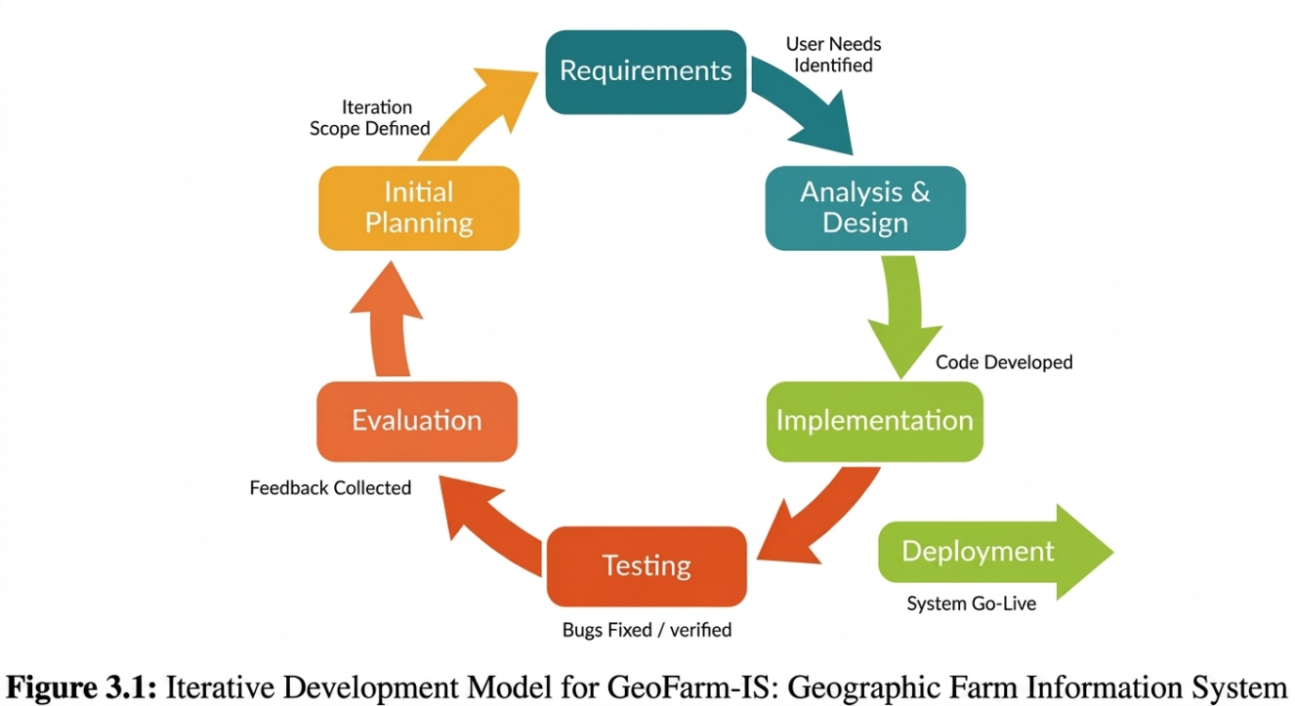
Source: Adapted from Sommerville (2016) and Pressman (2014).
The process follows a step-by-step and organized approach consisting of eight main stages. Requirements Gathering identifies user needs and defines the scope of each iteration. Analysis and Design creates the system architecture, database schema, and user interface based on the gathered requirements. Development builds the system modules incrementally, with each module developed, tested, and reviewed before proceeding to the next. Unit Testing verifies that individual components and functions work correctly, with bugs fixed and verified before proceeding.
Feedback Collection gathers input from stakeholders after each iteration, which is used to make necessary improvements to the established system. Evaluation Using ISO 25010 assesses the system's quality across eight characteristics: Functional Suitability, Performance Efficiency, Compatibility, Usability, Reliability, Security, Maintainability, and Portability. Implementation deploys the system for pilot use in the Municipal Agriculture Office, and Deployment (System Go-Live) makes the system available for actual use.
This approach enables a flexible development process that successfully adapts to changing requirements while ensuring that the final system meets the needs of its intended users. According to Sommerville (2016), iterative development allows for early detection of errors and continuous refinement based on user feedback, which is particularly important for systems like GeoFarm-IS that involve multiple interconnected modules and diverse user groups.
PHASE 1: REQUIREMENTS GATHERING
During the requirements gathering phase, agricultural officers, data encoders, and selected farmers were involved in a thorough assessment to determine specific needs and gain an understanding of the existing agricultural information management procedures. It was essential to understand the processes in the Municipal Agriculture Office, including farmer registration, farm parcel mapping, crop production tracking, livestock inventory management, assistance program distribution, and report generation.
By examining the existing administrative procedures, the researchers identified inefficiencies that the manual system failed to address, such as data management issues, time-consuming processes, poor accessibility and retrieval, security and confidentiality risks, limited GIS mapping capabilities, and inadequate reporting features.
The researchers used several data gathering methods to determine reference points for the web-based Geographic Farm Information System:
Internet Research. The researchers used a variety of Internet sources to collect data for the study. The internet provided access to numerous resources, including research papers, articles, and applications relevant to agricultural information systems, GIS mapping technologies, and crop yield prediction models.
Questionnaires. The researchers provided a set of questions given to agricultural officers, IT experts, farmers, and data encoders to evaluate the web application and for system testing. The questionnaire items were aligned with the ISO 25010 quality characteristics and the specific role of each respondent group.
Interview. To obtain important details regarding the Geographic Farm Information System and identify potential issues, the researchers conducted interviews with participants from the Municipal Agriculture Office, including the Municipal Agriculturist, agricultural technicians, and selected farmers. The interviews gathered details about the current workflow, common problems, reporting needs, assistance distribution basis, damage documentation, and user expectations.

PHASE 2: ANALYSIS AND DESIGN
The system architecture, database schema, user interface, security framework, and predictive analytics algorithm were designed based on the gathered requirements. Entity-Relationship Diagrams (ERD), Data Flow Diagrams (DFD), Use Case Diagrams, and wireframes were created to guide the development process.
System Architecture. GeoFarm-IS follows a three-tier client-server architecture comprising the Presentation Layer (React 18 with Inertia.js), Business Logic Layer (Laravel 12), and Data Layer (MySQL with PostGIS). This separation supports maintainability, controlled access to data, and independent development of system components.
Database Design. The database schema was designed to store farmer profiles, farm parcels, crop seasons, livestock records, assistance data, user access records, and audit logs. The schema includes twenty-eight tables organized into six functional domains: user and access management, farmer identity and location, farm parcels and crop seasons, livestock and agricultural assets, financial assistance, and audit records.
User Interface Design. Wireframes were created for all major user interfaces, including role-specific dashboards, farmer registration forms, seasonal tracking interfaces, GIS map views, and assistance management screens.
Security Framework. The system implements role-based access control, password encryption, CSRF protection, and data validation to ensure the security of farmer profiles, farm records, assistance history, and user accounts.
Predictive Analytics Design. The predictive analytics module was designed using rule-based and statistical approaches to classify farmers according to risk level based on seasonal production records, input costs, yield history, and previous crop performance.
PHASE 3: DEVELOPMENT
The system was developed iteratively through five modules:
Module | Description
Module 1: Farmer Registry and QR Code Management | Comprehensive farmer profiles with photo upload, RSBSA information, farm parcel details, organization membership, and QR-coded identification.
Module 2: Seasonal Agricultural Tracking | Crop records, production data, input information, livestock inventory, and related agricultural assets per dry and wet season.
Module 3: GIS Mapping | Visualization of farm parcels and barangay-level agricultural information using encoded or GPS-collected coordinates with Leaflet.js.
Module 4: Predictive Farmer Analytics | Risk classification based on seasonal production records, input costs, yield history, and previous crop performance.
Module 5: Financial Assistance, Livestock Tracking, Reports, and Dashboard | Recording assistance programs, farmer beneficiaries, claim status, distribution history, livestock inventory, and report generation.
Each module was developed, tested, and reviewed before proceeding to the next module. Feedback from stakeholders was incorporated to ensure the system met user requirements.
The researchers used the following software tools shown in Table 3-1 during the development of GeoFarm-IS.
Table 3-1. Software Requirements for Development
Description | Used
Browser | Google Chrome, Microsoft Edge, Opera and others
Text Editor | Visual Studio Code
Version Control | GitHub
Local server | XAMPP
Programming Language  Database  GIS Library | PHP, React JS, Tailwind CSS  MySQL 8.0  Leaflet.js, React-Leaflet
Operating System | Windows 11 (or newer)
MS Office | Word and Excel

Table 3-2. Hardware Requirements for Development
Description | Used
CPU | 11th Gen Intel® Core™ i5-1135G7 @ 2.40GHz  2.419Mhz
RAM | 8GB (or higher)
Hard Disk | 256GB SSD (or higher)
Monitor | 15.6” FHD (or external monitor with at least  1080p resolution)
Mouse and Keyboard | Standard USB/Wireless
Printer | Laser or Inkjet Printer (for document printing)
System Type | 64-bit Operating System, x64-based processor

PHASE 4: UNIT TESTING
Functionality testing was conducted using Unit Testing to ensure that all features of the web-based Geographic Farm Information System operated correctly according to the specified requirements. This included verifying that each function produced the expected output and behaved appropriately under normal and exceptional conditions.
Criteria For Unit Testing:
The following criteria were checked during unit testing and functionality testing. Each criterion was marked as Passed, Failed, or Needs Revision based on the expected output of the function being tested.
- User Login and Authentication
- User and Access Management
- Data Accuracy
- Dashboard Functionality
- Farmer Registration and Profiling
- Farm Parcel Management
- GIS Mapping and Spatial Data
- Crop Production Tracking (Seasonal)
- Livestock Inventory Management
- Agricultural Assets Tracking (Tree Crops, Fishponds)
- Assistance Program Management
- Distribution Tracking
- Predictive Analytics
- Security Features
- Result Generation and Reports
- Performance Under Load
- Accessibility and Compatibility
- Error Handling and System Feedback
PHASE 5: FEEDBACK COLLECTION
Feedback was collected from stakeholders after each iteration. This feedback was used to make necessary improvements to the established system before proceeding to the next iteration. The researchers used the feedback to correct errors, improve usability, and confirm whether the system met the requirements identified during data collection and management.
The feedback mechanism is represented in Figure 3.1 as the continuous loop that connects Testing → Feedback Collected → Evaluation → Implementation → Deployment → Requirements. This ensures that user input and testing results are continuously incorporated into the development process, allowing for iterative refinement of the system.
PHASE 6: EVALUATION USING ISO 25010
The developed system was evaluated using the ISO 25010 Software Quality Standard across eight quality characteristics:
a. Functional Suitability – The evaluation determined whether the required functions of GeoFarm-IS are complete, correct, and appropriate for user needs.
b. Performance Efficiency – The evaluation determined whether the system responds within an acceptable time during normal and data-intensive operations such as GIS viewing and report generation.
c. Compatibility – The evaluation determined whether the system works properly across supported browsers, devices, and network conditions.
d. Usability – The evaluation determined whether the interface, navigation, labels, instructions, and feedback messages are understandable to the intended users.
e. Reliability – The evaluation determined whether the system performs consistently and can handle errors or interruptions without losing important data.
f. Security – The evaluation determined whether the system protects records through login control, role-based permissions, validation, and audit logging.
g. Maintainability – The evaluation determined whether the system can be modified, debugged, and improved through clear structure and documentation.
h. Portability – The evaluation determined whether the system can be installed or transferred to the intended deployment environment with minimal changes.
PHASE 7: IMPLEMENTATION
The system was deployed to the Municipal Agriculture Office for pilot implementation. This included setting up the required software environment, preparing the database, creating user accounts, assigning roles, and conducting basic user orientation.
The implementation phase serves as the bridge between development and full deployment, allowing the researchers to test the system in a real-world environment and gather initial feedback before the system goes live.
PHASE 8: DEPLOYMENT (SYSTEM GO-LIVE)
The deployment phase of the system involved making the system available for actual use in the Municipal Agriculture Office. This included setting up the essential software environment, installing the system on the required computers or servers, and establishing user accounts with the proper responsibilities and access levels. Basic training was provided to agricultural officers and data encoders to ensure they understood how to operate the system correctly.
An acceptance test was also conducted with stakeholders to confirm that the system worked as intended. Authorized users were able to handle farmer profiles, farm parcel mapping, GIS visualization, crop production tracking, livestock inventory, assistance program distribution, predictive analytics, and report generation after the system was installed. This phase marked the completion of the development cycle and provided the basis for future improvements based on user feedback and performance evaluations.
The following software and hardware requirements were needed to deploy the developed system.

Table 3-3. Software Requirements for Deployment
Description | Used
Browser | Google Chrome, Microsoft Edge, Opera and others
Local server | XAMPP
Database Engine | MySQL
Operating System | Windows 11
MS Office | Word and Excel

Table 3-4. Hardware Requirements for Deployment
Description | Used
CPU | 11th Gen Intel® Core™ i5-1135G7 @ 2.40GHz  2.419Mhz
RAM | 8GB
Hard Disk | 256GB SSD (or higher)
Monitor | 15.6” FHD (or external monitor with at least 1080p resolution)
Mouse and Keyboard | Standard USB/Wireless
Printer | Laser or Inkjet Printer (for document printing)
System Type | 64-bit Operating System, x64-based processor

RESPONDENTS OF THE STUDY
To gather evaluation data for the study, the researchers selected agricultural officers, IT experts, and farmers as the respondent groups.
Table 3-5. Frequency Distribution of Respondents
Respondents | Frequency | Percentage
IT Experts | 5 | 16.67%
Agricultural Officers | 15 | 50%
Farmers | 10 | 33.33%
Total | 30 | 100%

Table 3-5 presents the proposed 30 respondents for the study, consisting of 5 IT experts, 15 agricultural officers, and 10 farmers. The IT experts evaluated the technical quality of the system, the agricultural officers evaluated office workflow and reporting needs, and the farmers evaluated user access, clarity of information, and usefulness of alerts or recommendations.
SAMPLING TECHNIQUE
The respondents were selected using a non-probability purposive sampling technique. This method allowed the researchers to choose participants based on their role, experience, and relevance to the system. IT experts were selected for their technical background, agricultural officers for their direct involvement in the office workflow, and farmers for their experience as end users of agricultural services.
STATISTICAL TREATMENT
The researchers measured the participants' responses using a 5-point Likert
scale. The scale was used to interpret the level of agreement and the perceived quality of the system based on the evaluation instrument.
Table 3-6. Likert Scale Interpretation for System Evaluation
Numerical Scale | Range | Interpretation
5 | 4.21 – 5.00 | Excellent – All features met functional and quality requirements; system is deployment-ready.
4 | 3.41 – 4.20 | Very Good – Minor issues found; overall system is reliable and performs well.
3 | 2.61 – 3.40 | Fair – Acceptable performance; several functions or qualities need improvement.
2 | 1.81 – 2.60 | Poor – Major issues exist in functionality or quality attributes; needs rework.
1 | 1.00 – 1.80 | Very Poor – System fails to meet core requirements; not ready for deployment.

Frequency Count and Percentage Formula
To calculate the percentage distribution of respondents and evaluation results, the researchers used the following formula:
$$p=\frac{f}{N}×100$$
Where:
- $p$ = percentage
- $f$ = frequency
- $N$ = total number of respondents
- $100$ = constant
Weighted Mean Formula
In finding the weighted mean, the researchers used the following formula:
$$\overset{ˉ}{x}=\frac{∑(f×x)}{N}$$
Where:
- $\overset{ˉ}{x}$ = Weighted Mean
- $f$ = Number of respondents
- $x$ = Rating value (1-5)
- $N$ = Total number of respondents
Research Instruments
The primary instrument for system evaluation is an ISO 25010-based structured questionnaire composed of three sections corresponding to the evaluated quality characteristics and respondent groups. Each section contained specific statements rated using a 5-point Likert scale.

A. Questionnaire for IT Experts. The IT experts evaluated the system based on the eight ISO 25010 quality characteristics: Functional Suitability, Performance Efficiency, Compatibility, Usability, Reliability, Security, Maintainability, and Portability. This group assessed the technical quality, system architecture, code structure, security implementation, and overall software performance to determine the system's compliance with software quality standards.

B. Questionnaire for Agriculture Office Staff. The Agriculture Office Staff evaluated the system from an operational perspective. Their assessment focused on the five core modules: Farmer Registry and QR Code Management, Seasonal Agricultural Tracking, GIS Mapping, Predictive Farmer Analytics, and Financial Assistance, Livestock Tracking, Reports, and Dashboard. This group assessed the system's usability, functionality, efficiency, and relevance to daily office operations and workflow requirements.

C. Questionnaire for Farmers. The Farmers evaluated the system from an end-user perspective. Their assessment focused on usability and access, QR-coded identification, status alerts and recommendations, data security and privacy, and overall satisfaction. This group provided feedback on the clarity of information presented, the usefulness of alerts and recommendations, and the overall experience of using the system for accessing their farm records and assistance information.

All items are rated on a five-point Likert scale: 5 – Strongly Agree, 4 – Agree, 3 – Neutral, 2 – Disagree, 1 – Strongly Disagree. The instrument was validated by the thesis adviser and reviewed for content validity before administration. The complete questionnaires are presented in the appendices.

A. Questionnaire for IT Experts
Instructions: Please rate each statement using the following scale:
Rating | Interpretation
5 | Strongly Agree
4 | Agree
3 | Neutral
2 | Disagree
1 | Strongly Disagree
Functional Suitability
Statement | 5 | 4 | 3 | 2 | 1
1. The system functions perform according to the stated requirements. | ☐ | ☐ | ☐ | ☐ | ☐
2. All required modules (Farmer Registry, Seasonal Tracking, GIS Mapping, Predictive Analytics, Financial Assistance) are complete and operational. | ☐ | ☐ | ☐ | ☐ | ☐
3. The system correctly processes and stores farmer, crop, livestock, and assistance data. | ☐ | ☐ | ☐ | ☐ | ☐
4. The predictive analytics module correctly classifies farmers according to risk level. | ☐ | ☐ | ☐ | ☐ | ☐
5. The system generates accurate and complete reports as required by the office. | ☐ | ☐ | ☐ | ☐ | ☐
Performance Efficiency
Statement | 5 | 4 | 3 | 2 | 1
1. The system responds quickly to user actions (page loads, searches, form submissions). | ☐ | ☐ | ☐ | ☐ | ☐
2. The GIS map renders parcel data within an acceptable time. | ☐ | ☐ | ☐ | ☐ | ☐
3. Reports are generated without significant delays. | ☐ | ☐ | ☐ | ☐ | ☐
4. The system can handle multiple concurrent users without performance issues. | ☐ | ☐ | ☐ | ☐ | ☐
5. The system efficiently uses server resources during data-intensive operations. | ☐ | ☐ | ☐ | ☐ | ☐
Compatibility
Statement | 5 | 4 | 3 | 2 | 1
1. The system works correctly across different web browsers (Chrome, Edge, Firefox). | ☐ | ☐ | ☐ | ☐ | ☐
2. The system is accessible from different devices (desktop, laptop, tablet). | ☐ | ☐ | ☐ | ☐ | ☐
3. The system displays properly on different screen sizes. | ☐ | ☐ | ☐ | ☐ | ☐
4. The system can export data in standard formats (PDF, Excel). | ☐ | ☐ | ☐ | ☐ | ☐
5. The system operates consistently across different operating systems. | ☐ | ☐ | ☐ | ☐ | ☐
Usability
Statement | 5 | 4 | 3 | 2 | 1
1. The user interface follows established design patterns and is easy to navigate. | ☐ | ☐ | ☐ | ☐ | ☐
2. Input validation and error messages are clear and helpful. | ☐ | ☐ | ☐ | ☐ | ☐
3. The system provides appropriate feedback for user actions. | ☐ | ☐ | ☐ | ☐ | ☐
4. Navigation is intuitive and consistent across all modules. | ☐ | ☐ | ☐ | ☐ | ☐
5. Role-based menus and functions are properly implemented for each user type. | ☐ | ☐ | ☐ | ☐ | ☐
Reliability
Statement | 5 | 4 | 3 | 2 | 1
1. The system operates consistently without crashes or failures. | ☐ | ☐ | ☐ | ☐ | ☐
2. Error handling is implemented properly without exposing sensitive information. | ☐ | ☐ | ☐ | ☐ | ☐
3. Data integrity is maintained across all operations. | ☐ | ☐ | ☐ | ☐ | ☐
4. The system recovers properly from unexpected interruptions. | ☐ | ☐ | ☐ | ☐ | ☐
5. The audit log accurately records all user activities and system events. | ☐ | ☐ | ☐ | ☐ | ☐

Security
Statement | 5 | 4 | 3 | 2 | 1
1. User authentication is properly implemented and secure. | ☐ | ☐ | ☐ | ☐ | ☐
2. Password storage uses industry-standard encryption (bcrypt). | ☐ | ☐ | ☐ | ☐ | ☐
3. Role-based access control effectively restricts unauthorized access. | ☐ | ☐ | ☐ | ☐ | ☐
4. The system is protected against common vulnerabilities (SQL injection, XSS, CSRF). | ☐ | ☐ | ☐ | ☐ | ☐
5. Audit logs comprehensively track all user activities and data changes. | ☐ | ☐ | ☐ | ☐ | ☐

Maintainability
Statement | 5 | 4 | 3 | 2 | 1
1. The source code is well-organized and follows coding standards. | ☐ | ☐ | ☐ | ☐ | ☐
2. The code is properly commented and documented. | ☐ | ☐ | ☐ | ☐ | ☐
3. The system can be easily updated or modified when needed. | ☐ | ☐ | ☐ | ☐ | ☐
4. The database design follows normalization principles. | ☐ | ☐ | ☐ | ☐ | ☐
5. System defects can be identified and corrected efficiently. | ☐ | ☐ | ☐ | ☐ | ☐

Portability
Statement | 5 | 4 | 3 | 2 | 1
1. The system can be deployed on different servers with minimal configuration. | ☐ | ☐ | ☐ | ☐ | ☐
2. System dependencies are clearly documented. | ☐ | ☐ | ☐ | ☐ | ☐
3. The system is scalable for future growth and additional users. | ☐ | ☐ | ☐ | ☐ | ☐
4. The system can be migrated to other platforms with minimal effort. | ☐ | ☐ | ☐ | ☐ | ☐
5. The system supports future integration requirements. | ☐ | ☐ | ☐ | ☐ | ☐

B. Questionnaire Agricultural office Staff
Instructions: Please rate each statement using the following scale:
Rating | Interpretation
5 | Strongly Agree
4 | Agree
3 | Neutral
2 | Disagree
1 | Strongly Disagree
Farmer Registry and QR Code Management
Statement | 5 | 4 | 3 | 2 | 1
1. The farmer registry captures the information needed by the office. | ☐ | ☐ | ☐ | ☐ | ☐
2. The process of adding and updating farmer records is clear and easy to follow. | ☐ | ☐ | ☐ | ☐ | ☐
3. The QR-coded farmer identification speeds up office transactions. | ☐ | ☐ | ☐ | ☐ | ☐
4. Farmer records are easy to search, retrieve, and update. | ☐ | ☐ | ☐ | ☐ | ☐
5. The system prevents duplicate farmer entries. | ☐ | ☐ | ☐ | ☐ | ☐

Seasonal Agricultural Tracking
Statement | 5 | 4 | 3 | 2 | 1
1. Crop production data is consistently tracked per farmer per season. | ☐ | ☐ | ☐ | ☐ | ☐
2. Livestock inventory is regularly monitored and updated. | ☐ | ☐ | ☐ | ☐ | ☐
3. Tree crops and fishponds are properly documented in the system. | ☐ | ☐ | ☐ | ☐ | ☐
4. Agricultural inputs (seeds, fertilizers, pesticides) are recorded properly. | ☐ | ☐ | ☐ | ☐ | ☐
5. The system helps organize seasonal records for reporting and analysis. | ☐ | ☐ | ☐ | ☐ | ☐

GIS Mapping
Statement | 5 | 4 | 3 | 2 | 1
1. The GIS map helps locate and monitor farm information. | ☐ | ☐ | ☐ | ☐ | ☐
2. Farm parcels are accurately displayed on the map. | ☐ | ☐ | ☐ | ☐ | ☐
3. The map provides useful information for field visits and planning. | ☐ | ☐ | ☐ | ☐ | ☐
4. Crop distribution and livestock density can be visualized on the map. | ☐ | ☐ | ☐ | ☐ | ☐
5. The GIS map is easy to navigate and use. | ☐ | ☐ | ☐ | ☐ | ☐

Predictive Analytics and Crop Recommendations
Statement | 5 | 4 | 3 | 2 | 1
1. The system helps identify farmers at risk of financial loss ("palugi"). | ☐ | ☐ | ☐ | ☐ | ☐
2. The risk classifications (low, medium, high, critical) are useful for planning. | ☐ | ☐ | ☐ | ☐ | ☐
3. The system provides useful recommendations for farmers based on their records. | ☐ | ☐ | ☐ | ☐ | ☐
4. The predictive analytics module uses appropriate data for risk assessment. | ☐ | ☐ | ☐ | ☐ | ☐
5. The system helps prioritize farmers for assistance and intervention. | ☐ | ☐ | ☐ | ☐ | ☐

Financial Assistance and Livestock Tracking
Statement | 5 | 4 | 3 | 2 | 1
1. Assistance records and distribution status are easy to track. | ☐ | ☐ | ☐ | ☐ | ☐
2. The system helps verify eligible farmers for assistance programs. | ☐ | ☐ | ☐ | ☐ | ☐
3. Distribution history is properly recorded and accessible. | ☐ | ☐ | ☐ | ☐ | ☐
4. Livestock inventory is easy to update and monitor. | ☐ | ☐ | ☐ | ☐ | ☐
5. The system provides transparency and audit trail for assistance distribution. | ☐ | ☐ | ☐ | ☐ | ☐

Reports and Dashboard
Statement | 5 | 4 | 3 | 2 | 1
1. The generated reports are useful for office work and decision-making. | ☐ | ☐ | ☐ | ☐ | ☐
2. Reports can be generated quickly and in the required format. | ☐ | ☐ | ☐ | ☐ | ☐
3. The dashboard provides a clear overview of agricultural data and key metrics. | ☐ | ☐ | ☐ | ☐ | ☐
4. The system helps reduce the time spent on manual report preparation. | ☐ | ☐ | ☐ | ☐ | ☐
5. Reports are accurate and complete based on the available records. | ☐ | ☐ | ☐ | ☐ | ☐

Overall Satisfaction
Statement | 5 | 4 | 3 | 2 | 1
1. The system improves the efficiency of office operations. | ☐ | ☐ | ☐ | ☐ | ☐
2. The system is easy to learn and use for daily tasks. | ☐ | ☐ | ☐ | ☐ | ☐
3. The system meets the needs of the Agriculture Office. | ☐ | ☐ | ☐ | ☐ | ☐
4. I would recommend this system to other agriculture offices. | ☐ | ☐ | ☐ | ☐ | ☐
5. I am satisfied with the overall performance of the system. | ☐ | ☐ | ☐ | ☐ | ☐

C. Questionnaire for Farmer
Instructions: Please rate each statement using the following scale:
Rating | Interpretation
5 | Strongly Agree
4 | Agree
3 | Neutral
2 | Disagree
1 | Strongly Disagree

Usability and Access
Statement | 5 | 4 | 3 | 2 | 1
1. The system presents farmer information in a way that is easy to understand. | ☐ | ☐ | ☐ | ☐ | ☐
2. The process of viewing my farm records and history is clear and simple. | ☐ | ☐ | ☐ | ☐ | ☐
3. The system is easy to access and navigate. | ☐ | ☐ | ☐ | ☐ | ☐
4. I can easily find the information I need about my farm and assistance history. | ☐ | ☐ | ☐ | ☐ | ☐
5. The system helps me become more aware of my previous crop records and assistance history. | ☐ | ☐ | ☐ | ☐ | ☐

QR-Coded Identification
Statement | 5 | 4 | 3 | 2 | 1
1. The QR-coded identification can help speed up office transactions. | ☐ | ☐ | ☐ | ☐ | ☐
2. The QR code card is easy to present when transacting with the Agriculture Office. | ☐ | ☐ | ☐ | ☐ | ☐
3. The QR code helps reduce the need for filling out forms repeatedly. | ☐ | ☐ | ☐ | ☐ | ☐
4. I feel confident that my information is properly recorded and accessible. | ☐ | ☐ | ☐ | ☐ | ☐

Status, Alerts, and Recommendations
Statement | 5 | 4 | 3 | 2 | 1
1. The system provides useful alerts or recommendations based on my farm records. | ☐ | ☐ | ☐ | ☐ | ☐
2. The alerts help me understand if my farm is at risk of financial loss. | ☐ | ☐ | ☐ | ☐ | ☐
3. The recommendations are practical and easy to understand. | ☐ | ☐ | ☐ | ☐ | ☐
4. The system helps me track the status of my assistance requests. | ☐ | ☐ | ☐ | ☐ | ☐
5. The information provided by the system helps me make better farming decisions. | ☐ | ☐ | ☐ | ☐ | ☐

Data Security and Privacy
Statement | 5 | 4 | 3 | 2 | 1
1. I feel that my personal and farm data are handled properly. | ☐ | ☐ | ☐ | ☐ | ☐
2. I trust that my information is secure and will not be shared without permission. | ☐ | ☐ | ☐ | ☐ | ☐
3. I am comfortable with the system storing my farm records digitally. | ☐ | ☐ | ☐ | ☐ | ☐
4. The system helps me organize my farm records more easily. | ☐ | ☐ | ☐ | ☐ | ☐

Overall Satisfaction
Statement | 5 | 4 | 3 | 2 | 1
1. I am satisfied with the services provided through the system. | ☐ | ☐ | ☐ | ☐ | ☐
2. The system improves the way I interact with the Agriculture Office. | ☐ | ☐ | ☐ | ☐ | ☐
3. I would recommend this system to other farmers. | ☐ | ☐ | ☐ | ☐ | ☐
4. The system meets my expectations as a farmer. | ☐ | ☐ | ☐ | ☐ | ☐
5. I feel that the system supports farmers in improving their farm management. | ☐ | ☐ | ☐ | ☐ | ☐

D. OPEN-ENDED QUESTIONS
For Agriculture Office Staff / IT Experts (Interview)
- What are the common problems encountered in farmer registration and record updating?
- What reports are usually needed by the office, and how are they prepared?
- What information is used as basis for distributing seeds, fertilizers, financial assistance, or other support?
- How are crop damages and insurance-related documents currently recorded?
- What features should be prioritized to make the system useful in daily office work?
For Farmers (Interview)
- What difficulties do you experience when updating records or requesting assistance?
- What farm or crop information do you want to view more easily?
- What type of alerts or recommendations would be useful to you after each cropping season?
- What documents or evidence do you usually prepare when reporting crop damage?
- What concerns do you have about using a digital system for farmer records?

References
Philippine Agricultural Policies and LGU Systems
Republic Act No. 8435. (1997). Agriculture and fisheries modernization act (AFMA).
Republic Act No. 10601. (2013). Agricultural and fisheries machinery act.
Republic Act No. 11364. (2019). Philippine crop insurance corporation (PCIC) act.
Department of Agriculture. (2021). DA memorandum circular no. 09: Guidelines on the registry system for basic sectors in agriculture (RSBSA).
Philippine Statistics Authority. (2023). Census of agriculture and fisheries (CAF) 2022: Preliminary results.
Department of the Interior and Local Government. (2020). DILG memorandum circular 2020-094: Local government units support to agricultural programs.
Agricultural Training Institute. (2022). e-Extension program for farmers: Digital transformation in agriculture.
Philippine Council for Agriculture, Aquatic and Natural Resources Research and Development. (2021). Agriculture 4.0: Roadmap for digital agriculture in the Philippines.
Llanto, G. M. (2020). Challenges and opportunities for agricultural development in a post-COVID-19 economy. Philippine Institute for Development Studies.
Briones, R. M. (2019). Role of local government units in agricultural development. Philippine Institute for Development Studies.

Agricultural Information Systems and Farmer Registries
Banson, K. E., et al. (2021). Agricultural information systems: A systematic review of adoption and impact. Journal of Agricultural Informatics.
Delos Reyes, M. L., & Sanchez, F. M. (2022). Development of a web-based farmer registry system for local government units. International Journal of Advanced Computer Science and Applications.
Santos, R. A., et al. (2023). Digitizing farmer records: A case study on RSBSA implementation in Philippine LGUs. Philippine Journal of Public Administration.
Cruz, J. C., & Mendoza, A. B. (2021). Information systems for agricultural extension services in developing countries. Computers and Electronics in Agriculture.
Fernandez, P. L. (2022). Farmer data management systems: Best practices for local government implementation. Asian Journal of Technology Management.
Gomez, R. S., & Torres, M. C. (2020). Mobile and web-based platforms for agricultural data collection in rural areas. Information Technology for Development.
Rivera, J. P., et al. (2023). Design and implementation of a farmer profiling system for municipal agriculture offices. Journal of ICT Research and Applications.
Villanueva, E. A. (2021). Digital transformation in Philippine agriculture: Status, challenges, and prospects. SEARCA Policy Brief Series.
Mendoza, L. C., & Garcia, N. B. (2022). Agricultural data governance frameworks for local government units. Philippine Information Technology Journal.
Reyes, C. C., et al. (2020). QR code integration in government services: A case study on farmer identification systems. International Journal of Computing and Digital Systems.

Geographic Information Systems (GIS) in Agriculture
Burrough, P. A., & McDonnell, R. A. (2020). Principles of geographical information systems (4th ed.). Oxford University Press.
Longley, P. A., et al. (2022). Geographic information science and systems (5th ed.). Wiley.
Zhang, C., & Kovacs, J. M. (2021). The application of small unmanned aerial systems for precision agriculture: A review. Precision Agriculture.
De la Cruz, M. T., & Ramos, A. C. (2023). GIS-based mapping of agricultural land use in the Philippines. Philippine Journal of Science.
Sarmiento, J. P., et al. (2022). Geospatial analysis of crop distribution and productivity in Isabela Province. Asia Life Sciences.
Corpuz, R. S., & Lontoc, A. V. (2021). Web-based GIS for agricultural resource management in local government units. ISPRS International Journal of Geo-Information.
Mendoza, J. R., et al. (2023). Integrating satellite imagery and ground data for agricultural monitoring in the Philippines. Remote Sensing Applications: Society and Environment.
Castillo, L. M., & Rivera, F. T. (2020). GIS applications in Philippine agriculture: A review of current practices. Journal of Agricultural Extension and Rural Development.
Bautista, R. G., et al. (2022). Development of a web-based GIS platform for agricultural land use planning. Geocarto International.
Open Source Geospatial Foundation. (2024). QGIS documentation and training manual.
ESRI. (2023). ArcGIS enterprise: Architecture and deployment guide.
Tan, A. B., & Villar, S. D. (2021). Geospatial technologies for crop monitoring and yield prediction. International Journal of Agricultural and Biological Engineering.

Predictive Analytics in Agriculture
Liakos, K. G., et al. (2022). Machine learning in agriculture: A review. Sensors.
Kamilaris, A., & Prenafeta-Boldú, F. X. (2021). Deep learning in agriculture: A survey. Computers and Electronics in Agriculture.
Chlingaryan, A., et al. (2020). Machine learning approaches for crop yield prediction and nitrogen status estimation in precision agriculture: A review. Computers and Electronics in Agriculture.
Cruz, F. A., & Mendoza, R. B. (2023). Predictive modeling for agricultural risk assessment in developing countries. Agricultural Systems.
Dela Peña, B. L., et al. (2022). Development of a farmer risk prediction model using historical agricultural data. Philippine Journal of Agricultural Economics.
Garcia, J. M., & Santos, E. R. (2021). Data mining techniques for identifying at-risk farmers in agricultural programs. International Journal of Data Science and Analytics.
Lopez, P. R., et al. (2023). Machine learning approaches for predicting crop losses due to climate variability. Climate Risk Management.
Fernandez, L. A., & Ramos, M. S. (2022). Predictive analytics for agricultural support and intervention programs. Journal of Rural Studies.
Villanueva, R. M., et al. (2023). Time series analysis of agricultural production data for early warning systems. Computers and Electronics in Agriculture.
Aggarwal, P. K., et al. (2020). Climate risk management in agriculture: Approaches and tools. CAB International.
World Bank. (2022). Predictive analytics for agricultural resilience: A guide for developing countries. World Bank Group.
Jimenez, D. R., & Cruz, A. M. (2021). Decision support systems for smallholder farmers: A review of predictive tools. Agricultural Systems.

Software Development, GIS Libraries, and Analytics Frameworks
Laravel. (2025). Laravel 11.x documentation.
Stauffer, M. (2023). Laravel: Up and running. O’Reilly Media.
Leaflet. (2025). Leaflet: An open-source JavaScript library for mobile-friendly interactive maps.
OpenLayers. (2025). OpenLayers: A high-performance, feature-packed library for interactive maps.
Turf.js. (2025). Turf.js: Advanced geospatial analysis for browsers and Node.js.
Python Software Foundation. (2025). Python documentation: Scientific computing and data analysis libraries.
McKinney, W. (2022). Python for data analysis (3rd ed.). O’Reilly Media.
VanderPlas, J. (2023). Python data science handbook (2nd ed.). O’Reilly Media.
Géron, A. (2022). Hands-on machine learning with scikit-learn, keras, and tensorflow (3rd ed.). O’Reilly Media.
Pressman, R. S. (2022). Software engineering: A practitioner’s approach (9th ed.). McGraw-Hill.
Sommerville, I. (2021). Software engineering (10th ed.). Pearson.
Oracle Corporation. (2025). MySQL 8.4 reference manual.
Simple QrCode. (2025). Laravel QR code generator package documentation.
DomPDF. (2025). HTML to PDF converter for PHP.
Chart.js. (2025). Simple yet flexible JavaScript charting.

